Annual Air Monitoring Plan
2027



Maine Department of Environmental Protection
Bureau of Air Quality
June 29, 2026
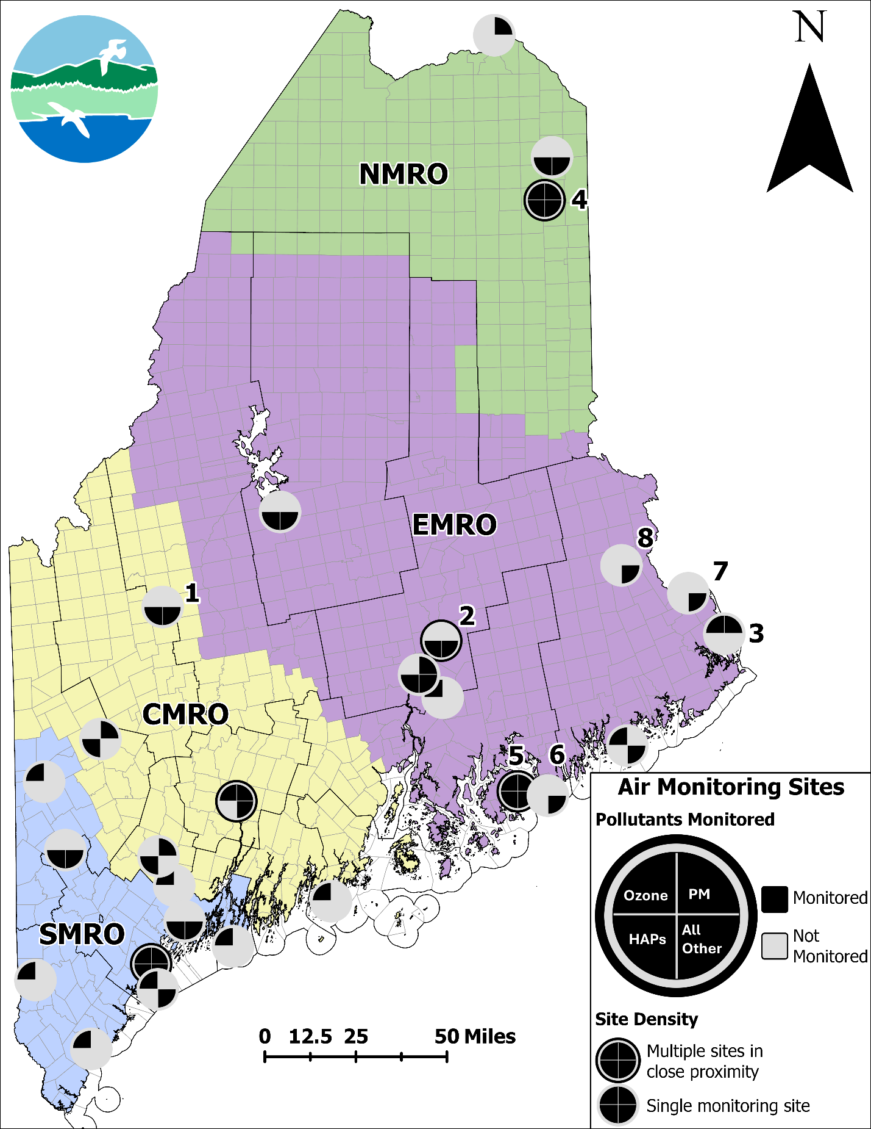
Maine's Air Monitoring Site Map

Maine’s Air Monitoring Site Map Details:
Monitoring Organizations:
While Maine DEP conducts the bulk of the air quality monitoring in the state, air quality data is collected by other organizations at multiple sites (numbered on map) around the state. These other organizations include the Penobscot Nation (sites 1 and 2), the Passamaquoddy Tribe of Sipayik (3), Mi’kmaq Nation (4), National Park Service (5 and 6), the US FWS (7), and Passamaquoddy Tribe of Indian Township (8).
Regional Offices:
Maine is split into four regions, with a DEP office in each region responsible for the sites in that region: Northern Maine Regional Office (NMRO) in green, Eastern Maine Regional Office (EMRO) in purple, Central Maine Regional Office (CMRO) in yellow, and Southern Maine Regional Office (SMRO) in blue.
Monitored Pollutants:
The DEP and other organizations in the state monitor a large array of air quality pollutants (e.g., ozone and particulate matter), along with supporting parameters (e.g., wind speed and direction) or research and trends parameters (e.g., particulate speciation or precipitation chemistry). Ozone, particulate matter (PM), and hazardous air pollutants (HAPs) are the dominant air quality pollutants of focus in the state, with at least one being collected at nearly every site in the state.
Map symbol descriptions:
The symbols used in the figure on page 1 have five elements indicated by either being filled (black) or empty (light grey).
The first four elements indicate the presence of pollutant monitoring being conducted at that site. Each of these four elements are one quadrant of a complete circle, with the top left for ozone, top right for continuous PM, and bottom left for HAPs. The bottom right quadrant is for all other pollutants and parameters collected and measured.
The final element is a ring on the outer edge of the circle. This ring is used where the site density is too high, and a single symbol is being used to indicate multiple sites. A quadrant is filled if any site represented by the symbol has the appropriate pollutant.
There are 22 single site symbols used in figure 1, and five multiple site symbols, located in Portland and South Portland (9 sites), Augusta (3 sites), Bar Harbor (2 sites), Old Town, Indian Island and Alton (4 sites) and Presque Isle (3 sites). The monitoring network, monitoring site types and their objectives, and pollutants monitored are described in detail in this document.

Table of Contents
Table of Acronyms, Abbreviations, and Shorthand 5
Introduction 8
Network Overview 11
Monitoring Site Types 13
SLAMS 13
NCore 13
Special Purpose Monitor 14
Enhanced Monitoring Plan 14
Tribal 15
Other/ Special networks 16
Monitoring Networks 18
Ozone Network 18
PM_{2.5} Network 20
PM₁₀ Network: 23
PM_{Coarse} Network: 24
Sulfur Dioxide Network: 25
Nitrogen Oxides Network (NO₂, NOx, NO, NOy): 26
Carbon Monoxide Network: 27
Hazardous Air Pollutants (HAPs) Network: 28
Meteorological Network: 29
Atmospheric Deposition Network: 32
PM Speciation Network (IMPROVE) 33
Lead Network: 33
Monitoring Projects and Air Quality Studies: 35
South Portland/Portland VOC Monitoring Project: 35
Hydrogen Sulfide: 39
Aeroallergens: 40
Cassidy Point: 41
Rumford Intra-Valley Transport Analysis: 41
Summaries 43
Summary of Proposed Network Changes: 43
Summary of Monitoring Equipment Used by the Maine DEP 44
Appendix A: Monitoring Station Information 45
Appendix 2: Wyman Station 80

Table of Acronyms, Abbreviations, and Shorthand
Acronym  (Alternate or similar) | Meaning  Additional information
1 in 3 | 24hr sample, from midnight EST to might EST, once every three days
1 in 6 | 24hr sample, from midnight EST to might EST, once every six days
1 in 12 | 24hr sample, from midnight EST to might EST, once every 12 days
AAG | Ambient Air Guidelines
AQI | Air Quality Index
AQS | Air Quality System
ARD | Air Resource Division  Division of the National Park Service
ARP | American Rescue Plan
BAM | Beta Attenuation Monitor
BAQ | Bureau of Air Quality
BRACE | Building Resilience Against Climate Effects
CASTNET | Clean Air Status and Trends Network
CBSA | Core-Based Statistical Area
CDC | Center for Disease Control
CFR | Code of Federal Regulations
CRDS | Cavity Ring Down Spectrometry
CO | Carbon monoxide
CO₂ | Carbon dioxide
CSN | Chemical Speciation Network
DACF | Department of Agriculture Conservation and Forestry
DAQA | Division of Air Quality Assessment
DEP | Department of Environmental Protection
DOT | Department of Transportation
DRR | Data Requirements Rule
EMP | Enhanced Monitoring Plan
EPA | Environmental Protection Agency
EQOA | Equivalent [method for] ozone analyzers  Federal designation given to automated ozone analyzers that meet set criteria
EQPM | Equivalent [method for] particulate matter  Federal designation given to automated and continuous PM monitors that meet set criteria
EQSA | Equivalent [method for] sulfur dioxide analyzers  Federal designation given to automated SO₂ analyzers that meet set criteria.
FEM | Federal Equivalent Method  Considered to have consistent, and accurate performance that is comparable to FRMs
FRM | Federal Reference Method  Standardized and accurate method for sampling and analyzing ambient air pollutants
GC | Gas Chromatograph or Gas Chromatography
H₂S | Hydrogen sulfide
HAP  (HAPS) | Hazardous air pollutants
IMPROVE | Interagency Monitoring of Protected Visual Environments
IRA | Inflation Reduction Act
LEA | [Maine] Lakes Environmental Association
MDN | Mercury Deposition Network  Network of the NADP
MET | Meteorology
MSA | Metropolitan statical area
NAAQS | National Ambient Air Quality Standards
NADP | National Atmospheric Deposition Program
NASA | National Aeronautics and Space Administration
NCORE  (NCore) | National Core Pollutant Monitoring Stations
NESCAUM | Northeast States Coordinated Air Use Management
NO | Nitrogen oxide
NO₂ | Nitrogen dioxide
NO_{Y} | Reactive oxides of nitrogen
NOAA | National Oceanic and Atmospheric Administration
NPS | National Park Service
NTN | National Trends Network  Network of the NADP
O₃ | Ozone
OC / EC | Organic carbon / elemental carbon
PAG | Pollen Advisory Group
PAH | Polycyclic aromatic hydrocarbons
PAMS | Photochemical Assessment Monitoring Station
PFAS | Perfluoroalkyl and polyfluoroalkyl substances
PFN | PFAS-NTN subnetwork  Subnetwork of the NADP NTN for PFAS compounds
PM | Particulate matter
PM₁₀ | Particulate matter with a diameter equal to and less than 10 micrometers
PM_{2.5} | Particulate matter with a diameter equal to and less than 2.5 micrometers
PM_{Coarse}  (PM_{c} or PM_{10-2.5}) | Particulate matter with a diameter equal to and less than 10 micrometers but greater than 2.5 micrometers
PQAO | Project Quality Assurance Organization
QA | Quality assurance
RFCA | Reference Method for carbon monoxide  Designated given to automated CO analyzers that meet set criteria
RFNA | Reference method for nitrogen dioxide  Designated given to automated NO₂ analyzers that meet set criteria
RFPS | Reference Method for Particulate Matter.  Designated given to 24-hour gravimetric PM sampling equipment that meet set criteria. Commonly referred to as the manual or filter-based method
RH | Relative humidity
RITA | Rumford Intra-valley Transport Analysis
SIP | State Implementation Plan
SLAMS | State or Local Air Monitoring Stations
SO₂ | Sulfur dioxide
SO₄ | Sulfate
SPM | Special Purpose Monitor
SPMS | Special Purpose Monitoring Station
TO-15 | Toxic Organics - 15  EPA Air monitoring and analysis designation
TPY | Ton per year
USEPA | United State Environmental Protection Agency
UV | Ultraviolet (light)
VOC (VOCS) | Volatile organic compounds
VSCC | Very sharp cut cyclone
XRF | X-ray fluorescence

Introduction
The Maine Department of Environmental Protection (DEP), Bureau of Air Quality (BAQ) operates and maintains a network of air samplers in the state to evaluate ambient air quality in Maine. The Code of Federal Regulations (CFR) and the Environmental Protection Agency (EPA) require state and local agencies to conduct ambient air quality monitoring to determine whether the ambient concentrations of pollutants in the state exceed EPA’s National Ambient Air Quality Standards (NAAQS). The State of Maine has been and remains in attainment with all NAAQS since 2004. Air quality data is also used to document trends that may be occurring in the concentrations of monitored pollutants and to support the Maine DEP by providing background information for the licensing program and, when necessary, the development of pollution control strategies. For many of the monitored pollutants, the BAQ maintains an automated polling and reporting technology that provides continuous hourly data to the public and scientific community. These data are also used for timely forecasting of regional air quality conditions for Maine citizens and visitors to the state.
The Maine BAQ has been monitoring air quality in Maine since the DEP was formed in 1972, working in partnership with the EPA to uphold the tenets of the 1970 Clean Air Act and subsequent amendments. The BAQ is responsible for most of the ambient air quality monitors located in Maine. Additional monitoring is conducted by several federal agencies such as the EPA, the National Park Service (NPS), the U.S. Fish and Wildlife Service, the U.S. Geological Survey, as well as several of the Indian tribes in Maine. In 2007, Maine BAQ entered into a Primary Quality Assurance Organization (PQAO) agreement with the Mi’kmaq Nation, the Passamaquoddy Tribe at Pleasant Point, and the Penobscot Indian Nation in Maine to conduct air monitoring with shared quality assurance plans, practices, and procedures.
The air monitoring program in Maine has evolved as air quality standards have tightened, scientific knowledge has improved, the levels of concern for different pollutants have evolved, and the technology to monitor these pollutants has developed. The DEP initially concentrated resources on neighborhood monitoring of air pollutants, primarily from local sources. As the impact on the ambient environment from local sources was reduced, the state monitoring network began to focus on establishing statewide background levels and improving air quality forecasts.
Maine is a state with many regions of varying topography. Pollutant impacts in one area of the state may be very different from pollutant impacts in another area. Mountain valleys in the western part of the state may experience higher pollution levels at times because of atmospheric inversions, which may trap ground-level pollution in the valleys for extended periods, whereas the coastal locations, with higher dispersion of pollutants due to the constant onshore and offshore winds, may not. Aroostook County may record higher particulate levels because of widespread farming operations and the type of soil found in the county. Southern Maine may record higher ozone levels because of air masses originating from other areas of the United States. Some pollutants monitored may even come from the other side of the world, such as particulates from volcanic eruptions, large forest fires, or emissions from less-controlled sources in some of the rapidly developing countries.
The DEP is also aware of heightened interest in air quality issues by Maine citizens. Many internet sites provide real-time or near real-time ambient air quality data. Low-cost air sensors are on the market and becoming more readily available. As a result, the citizens the DEP serves are more informed and frequently more engaged in air quality issues than ever before. That expanding knowledge is creating demand for broadened air quality monitoring across the state and increasing interest in monitoring for non-criteria pollutants, such as hazardous air pollutants (HAPs) and aeroallergens (e.g., pollen, dust, and mold).
The DEP must also comply with changing federal regulations. As more data are collected and more health study results are published, the impacts of various pollutants are reviewed. Pollution standards and controls may need to be updated to reflect revised recommendations. The EPA is required to review the NAAQS every five years, and changing standards may require the implementation of additional monitoring requirements. A list of the current NAAQS is presented below.
National Ambient Air Quality Standards (NAAQS)
The EPA has set National Ambient Air Quality Standards for six principal pollutants, which are called “criteria” air pollutants. The current standards are listed below in units of parts per million (ppm) by volume, parts per billion (ppb) by volume, and micrograms per cubic meter of air (µg/m³).

Pollutant | Primary/  Secondary | Averaging Time | Level | Form
Carbon monoxide (CO) | primary | 8 hours | 9 ppm | Not to be exceeded more than once per year
Carbon monoxide (CO) | primary | 1 hour | 35 ppm | Not to be exceeded more than once per year
Lead (Pb) | primary and secondary (1) | Rolling 3-month average | 0.15 μg/m³  (1) | Not to be exceeded
Nitrogen dioxide (NO₂) | primary | 1 hour | 100 ppb | 98th percentile of 1-hour daily maximum concentrations, averaged over 3 years
Nitrogen dioxide (NO₂) | primary and  secondary | 1 year | 53 ppb (2) | Annual Mean
Ozone (O₃) | primary and  secondary (3) | 8 hours | 0.070 ppm | Annual fourth-highest daily maximum 8-hour concentration, averaged over 3 years
Fine particle pollution (PM_{2.5}) | primary | 1 year | 9.0 μg/m³ | Annual mean, averaged over 3 years
Fine particle pollution (PM_{2.5}) | secondary | 1 year | 15.0 μg/m³ | Annual mean, averaged over 3 years
Fine particle Pollution (PM_{2.5}) | primary and  secondary | 24 hours | 35 μg/m³ | 98th percentile, averaged over 3 years
Coarse particle pollution (PM₁₀) | primary and  secondary | 24 hours | 150 μg/m³ | Not to be exceeded more than once per year on average over 3 years
Sulfur dioxide (SO₂) | Primary (4) | 1 hour | 75 ppb | 99th percentile of 1-hour daily maximum concentrations, averaged over 3 years
Sulfur dioxide (SO₂) | Secondary (5) | 1 year | 10 ppb | Annual mean, averaged over 3 years
(1) In areas designated nonattainment for the Pb standards prior to the promulgation of the current (2008) standards, and for which implementation plans to attain or maintain the current (2008) standards have not been submitted and approved, the previous standards (1.5 µg/m3 as a calendar quarter average) also remain in effect.
(2) The level of the annual NO₂ standard is 0.053 ppm. It is shown here in terms of ppb for the purposes of clearer comparison to the 1-hour standard level.
(3) Final rule signed October 1, 2015, and effective December 28, 2015. The previous (2008) O₃ standards are not revoked and remain in effect for designated areas. Additionally, some areas may have certain continuing implementation obligations under the prior revoked 1-hour (1979) and 8-hour (1997) O₃ standards.
(4) The previous SO₂ standards (0.14 ppm 24-hour and 0.03 ppm annual) will additionally remain in effect in certain areas: (1) any area for which it is not yet 1 year since the effective date of designation under the current (2010) standards, and (2)any area for which an implementation plan providing for attainment of the current (2010) standard has not been submitted and approved and which is designated nonattainment under the previous SO₂ standards or is not meeting the requirements of a SIP call under the previous SO₂ standards (40 CFR 50.4(3)). A SIP call is an EPA action requiring a state to resubmit all or part of its State Implementation Plan to demonstrate attainment of the required NAAQS.
(5) The 2024 rulemaking added a new annual secondary NAAQS in 40 CFR Part 50 without altering the 1971 secondary 3-hour SO₂ NAAQS. Note that some areas may have certain continuing implementation obligations.

Network Overview
By July 1st of each year, the DEP is required to submit to the EPA a proposed monitoring plan for the next calendar year. In 2006, the EPA also required states to make their proposed plan available for a 30-day comment period prior to submittal. The DEP annual monitoring plan is constantly subject to change as standards are revised, new pollutants of concern are identified, monitoring sites are no longer acceptable to property owners, and staffing and budget cuts affect the ability to meet program objectives. Consequently, the monitoring plan proposed in this document is our best effort to project what we will be able to do next year given our current standards, staffing, and budget constraints.
The Maine DEP BAQ monitors air quality as required by the 1970 Clean Air Act and subsequent amendments, the Code of Federal Regulations (CFR), and the federal EPA. Much of the monitoring effort focuses on the six criteria pollutants: ground-level ozone, particulate matter, sulfur dioxide, nitrogen dioxide, carbon monoxide, and lead.
Ozone monitoring continues to be a priority for the DEP. Ozone at ground level can trigger a variety of health effects, particularly in young children, older adults, and those with existing health conditions. It is also harmful to vegetation, buildings, and infrastructure. Ground-level ozone is not usually emitted directly into the air from a source but is created through the presence of sunlight acting on other airborne pollutants like those found in vehicle exhaust, chemical solvents, and gasoline vapors. The primary ozone precursors are nitrogen oxides and volatile organic compounds (VOCs). Since the Clean Air Act of 1970, Maine has operated ozone monitoring stations at many locations, each selected to optimize the assessment of ozone levels across the state.
Quantification of fine airborne particulate matter (PM_{2.5}) is another major component of the DEP ambient monitoring program. Particulate matter (PM) is the term used for any airborne mixture of solid particles and liquid droplets, such as those found in soot, dust, and smoke. The particles can be large enough, like pollen, to be seen with the unaided eye, while others are so fine that they can only be detected with electron microscopes. Of particular concern are those particles, generally 10 microns in size and less (PM₁₀), which are inhalable, for they can become lodged in the lungs. PM_{2.5} particles can be respired deeply into the lungs and even enter the bloodstream. PM_{2.5} monitoring in Maine has evolved since 1999 when the program was established. The total suspended particulates and PM₁₀ monitoring program in Maine began shortly after the DEP was established in 1972. DEP efforts have focused on introducing more of the continuous PM_{2.5} monitors into the network. Most monitoring sites where particulate sampling take place today include continuous PM_{2.5} and PM₁₀ monitors.
Nitrogen oxide (NO) and nitrogen dioxide (NO₂) together are referred to as oxides of nitrogen, or nitrogen oxides (NO_{x}), while the total reactive oxides of nitrogen (NO_{Y}) include the NO_{X} compounds, and higher oxide variants of nitrogen. EPA’s NAAQS uses NO₂; however, the common measurement method is an indirect calculation of NO₂ by measuring NO and NO_{X}, then subtracting NO from NO_{X}. NO is created during the combustion stage of engine and boiler operations. The NO, NO₂, NO_{x}, and NO_{y} forms of nitrogen oxides react at different rates in the atmosphere in a process that is dependent on sunlight and temperature. NO_{x} is measured at ground level while NO_{y} is the reactive form measured at ten meters above ground level. In addition to contributing to the formation of ground-level ozone and fine particle pollution, the oxides of nitrogen are linked with a number of adverse health effects on the respiratory system.
Sulfur dioxide (SO₂) and a group of other sulfur oxides, collectively known as SO_{x}, are emitted into the atmosphere from the burning of fossil fuels by power plants, industrial facilities, ships, locomotives, and heavy equipment. Short-term exposure to SO₂ and SO_{x} compounds can harm the respiratory system. Children, older adults, and those with asthma or other breathing problems are particularly sensitive to these sulfur compounds.
Carbon monoxide (CO) is another harmful gas emitted during combustion processes. Most of this colorless, odorless, yet extremely harmful gas comes from mobile sources such as cars and trucks, and in the United States it is found primarily in and around large urban areas. CO reduces the amount of oxygen that can be absorbed by the body, particularly the heart and the brain. At high concentrations, CO can lead to death.
Lead (Pb) is emitted into the atmosphere in particulate form – mainly from smelters, ore and metal processing facilities, waste incinerators, public utilities, and lead-acid manufactures. Since tetraethyl lead was removed from motor vehicle fuel in 1996, the ambient levels of lead in Maine have dropped significantly and concentrations are currently at or below minimum detection levels for most Pb monitors. Smaller piston aircraft (e.g., 2-10 passenger aircraft) continue to use leaded aviation fuel; however, the Federal Aviation Administration is working to eliminate leaded aviation fuel by the end of 2030.
The DEP also tests ambient air samples for many non-criteria yet hazardous air pollutants (HAPs). Based on the HAPs testing of ambient air, a priority list of hazardous pollutants was tabulated, and the DEP has established background concentrations for several of the pollutants on the list. The list is modified as additional data becomes available.
The following section details the individual networks for the various parameters monitored in Maine, lists any changes proposed for monitored parameters, and identifies future needs for monitoring. Though the spirit and intent of this document is to specify how the network will appear and function for calendar year 2027, the potential exists for additional short-notice changes to the network. If circumstances dictate a change to the network, proposed changes will still be made available for public review and comment prior to implementation.

Monitoring Site Types

SLAMS
Most of the sites in the Maine air monitoring network are designated as state or local air monitoring stations (SLAMS). The SLAMS in Maine are part of a standardized national network administered by the EPA in accordance with the Clean Air Act and subsequent federal regulations. Every state must monitor for the criteria air pollutants, following strict criteria set by the EPA that govern all aspects of the monitoring and reporting process. SLAMS sites must meet all stringent monitor siting requirements and utilize specified equipment types. The pollution monitoring instruments at these sites must be approved by the EPA and be designated as either a federal reference method (FRM) or a federal equivalent method (FEM). In addition, SLAMS site operators must follow all quality assurance criteria and must submit detailed quarterly and annual monitoring results to the EPA. Data from SLAMS locations are used as one of the factors to define attainment/nonattainment areas and to determine if an area is meeting the NAAQS.

NCore
Established in 2011, ‌‌‌‌‌‌‌the National Core (NCore) network is comprised of a specialized subset of SLAMS sites.
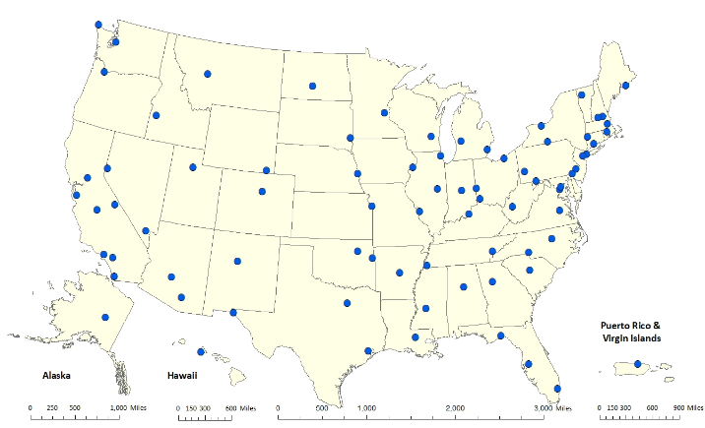
The purpose of the NCore network, in addition to aiding in the determination of nonattainment / attainment areas, is to provide data to the scientific community from a specific suite of monitors that are used to make health and ecosystem assessments, establish long-term trends for criteria and certain precursor pollutants, and develop and evaluate pollutant transportation models. The NCore site in Maine, located at McFarland Hill in Acadia National Park, near Bar Harbor, is designated as a rural / background site. At McFarland Hill the following parameters are monitored:

Air Pollutant Parameters Monitored at NCore Sites
PM_{2.5} speciation | Organic and elemental carbon, major ions and trace metals (24-hour average; every 3rd day); IMPROVE or CSN
PM_{2.5} FRM mass | Filter-based 24 hr. average every 3rd day
Continuous PM_{2.5} mass | 1-hour reporting interval; FEM
PM(_{10-2.5}) mass – aka PM_{Coarse} | Filter-based 24 hr. average every 3rd day or Continuous
Ozone (O₃) | Continuous, capable of trace levels (low ppm)
Carbon monoxide (CO) | Continuous, capable of trace levels (low ppm)
Sulfur dioxide (SO₂) | Continuous, capable of trace levels (low ppb)
Nitrogen oxide (NO) | Continuous, capable of trace levels (low ppb)
Total reactive nitrogen (NO_{y}) | Continuous, capable of trace levels (low ppb)
Surface meteorology | Continuous wind speed and direction (reported as “Resultant”), temperature, RH

Special Purpose Monitor
The Maine DEP routinely operates Special Purpose Monitors (SPM) around the state. SPMs are set up at locations to monitor specific pollutants for a short period, usually not exceeding two years, to investigate localized complaints, or to study a location for a possible long-term site.
The Portland Ocean Gateway monitoring site came online in January 2026, replacing the Dearing Oaks Park location that was shut down in August 2025. This location has a mix of SPM and SLAMs monitors being operated.

In the summer of 2026, the DEP plans to install hydrogen sulfide (H₂S) monitors at a new site in Old Town and at the preexisting Rumford site for a minimum of one year to assess health effects of nearby sources to the public.

Enhanced Monitoring Plan
The State of Maine is required to maintain an Enhanced Monitoring Plan (EMP) because it is within the ozone transport region as defined in 40 CFR, part 58, appendix d, paragraph 5(h). As part of this plan, as approved by the EPA on October 25, 2018, Maine maintained operation of a Photochemical Assessment Monitoring Station (PAMS) at Cape Elizabeth – Two Lights State Park (CETL) from 1993 to 2022. Monitoring at CETL began with year-round ozone, NO_{y}, meteorology, and, from June 1 to August 31, a continuous gas chromatography (GC) system measuring hourly concentrations of hydrocarbon VOCs.
A Pandora sun spectrometer was installed at CETL in 2021. This instrument measures vertical column densities (total columns) of trace gases in the atmosphere using sun and sky radiation in the UV visible part of the spectrum. Staff from the Maine DEP provide in-person support to keep the instrument running, and the EPA, NASA, and contractors provide data analysis and remote support. A major joint objective of this initiative is to support the validation and verification of more than a dozen low-earth orbit and geostationary orbit-based UV-visible satellites.
In October of 2022, after years of low concentrations and the need to refocus limited staff availability on other monitoring concerns within the state, the Maine DEP shut down the NO_{y} instrument and the GC system at CETL. The meteorology tower had to be replaced due to wear-related safety concerns. The replacement tower is not heavy duty, and to ensure the longevity of the tower through Maine winters, the meteorology equipment is only in operation during the ozone season. The ozone monitor at CETL continues to run year-round as it provides important early spring data for forecasters and modelers.
The new EMP plan for Maine includes the operation of ozone monitors beyond those minimally required under 40 CFR, part 58, appendix d, paragraph 4.1 as well as the enhanced monitoring of upper air pollution concentrations produced by the Pandora spectrometer.

Tribal
In the 1990 Clean Air Act, Congress recognized EPA’s obligation to work with the Tribes in addressing air quality on Tribal lands. EPA’s Tribal air policy emphasizes that, as sovereign governments, Tribes set their own air program goals and determine how monitoring is to be used in achieving these goals. Thus, EPA’s role for Tribal air programs is to help the Tribes understand their air quality problems and to establish and meet their air quality goals, rather than to set goals or timetables for the Tribes. As part of a shared PQAO between the Maine DEP, the Penobscot Nation, the Passamaquoddy Tribe at Pleasant Point, and the Mi’kmaq Nation, the Maine DEP works directly with the Tribal operators and administrators in a supporting role. This support varies among the Tribes: often minimal with only shared quality assurance practices and conducting performance evaluations for criteria pollutant monitors but occasionally extending to direct technical assistance and short/moderate-term loaning of monitoring equipment.

Other/ Special networks
CASTNET
The Clean Air Status and Trends Network (CASTNET) is a nationwide monitoring operation that collects air pollutant concentrations to evaluate the effectiveness of national and regional emission control programs, to determine compliance with the NAAQS for ozone, and to determine rural trends in ozone, nitrogen, and sulfur concentrations. The network was established in 1991 as a cooperative program with the EPA, the NPS, and state and local partners. The single CASTNET site location in Maine is at McFarland Hill in Acadia National Park. There was previously a second CASTNET site in Maine located in Ashland, but that site was unexpectedly shut down in May 2022 due to budget constraints. CASTNET data are incorporated in several regional air quality models.
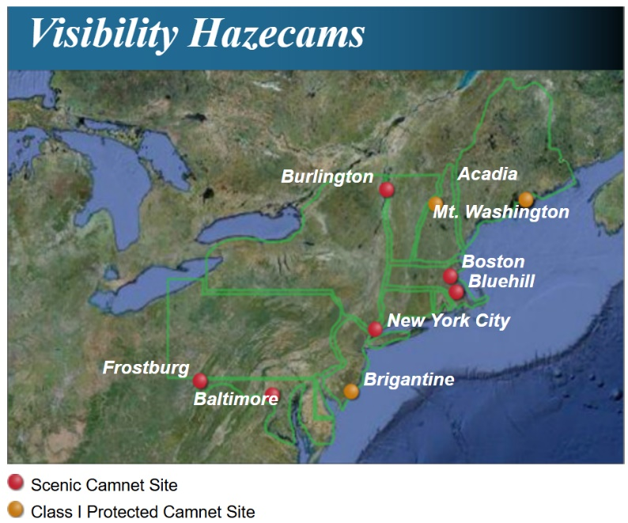
Camnet
Camnet is a network of real-time visibility cameras situated throughout the Northeastern United States that is coordinated by the Northeast States for Coordinated Air Use Management (NESCAUM). The Maine DEP, along with several other state and local agencies and non-profit organizations, helps support the operation of this network. In Maine, there is an active Camnet location at Schoodic Point with one wide-angle camera pointing west toward Acadia National Park on Mount Desert Island. Air quality sensors at the site allow users of Camnet to see the effects of air pollution on visibility.
RadNet
RadNet is the EPA’s radiation network. The EPA has historically maintained two RadNet sites in Maine with local operators: one site is in Freeport, the other is in Bangor, both operated by the DEP. Historically, one of these monitors was operated at the Portland Deering Oaks Park site and the second was operated by University of Maine staff in Orono. The Orono RadNet was moved to Bangor in August 2024, with DEP taking over local operation, and the Portland RadNet was moved to Freeport in August 2025 after the Deering Oaks site was shut down.
RadNet sites run 24 hours a day, 7 days a week collecting near real-time measurements of gamma radiation. In addition, high-volume air samplers collect particulates continuously at these two sites for laboratory radiation analysis. The full RadNet network includes 140 radiation air monitors in 50 states. The RadNet program monitors the nation’s air, precipitation, and drinking water to track radiation in the environment. Over time, RadNet sample testing and monitoring results show the fluctuations in background levels of environmental radiation. The RadNet system is also designed to detect higher than normal radiation levels during a radiological incident.
Gamma radiation comes from many different radioactive elements, both natural and man-made. Able to penetrate several feet of concrete or a few inches of lead, gamma particles can pose a serious health threat inside and outside the body and the radiation can be lethal depending on the amount received. Scientists use the properties of gamma radiation to detect the presence of radioactive elements. RadNet stationary air monitors measure gamma radiation emitted from airborne radioactive particles as they collect on the exposed filters. Tracking gamma radiation over time helps to create a picture of the background levels and allows EPA scientists to detect anomalies.
Other
Maine also works with the EPA and national contract labs to conduct PM chemical speciation (i.e., the IMPROVE network) and atmospheric deposition analysis. These networks are discussed in detail in the following section. Additionally, the NPS and the U.S. Fish and Wildlife Service operate monitoring sites in Maine as part of their respective networks.

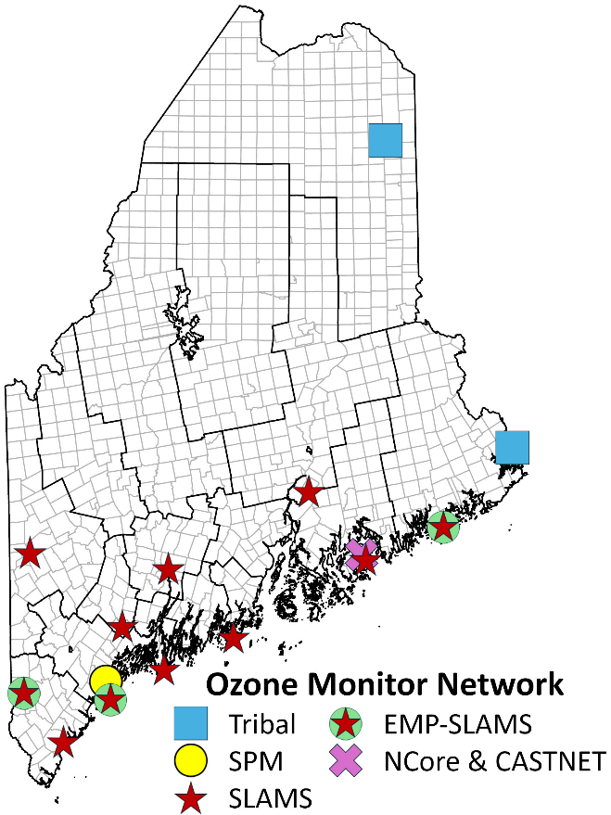
Monitoring Networks

Ozone Network
The DEP currently operates 12 ground-level ozone monitoring sites throughout the state in accordance with SLAMS network requirements as well as one additional special purpose monitoring station in Portland. Three of the DEP ozone sites operate year-round: Bar Harbor, Cape Elizabeth, and Portland. The remaining DEP ozone sites are seasonal, running April 1 through September 30 each year at a minimum. The Portland site is within a metropolitan area, and the data collected are used for human health studies rather than for regulatory purposes. Expanding on the DEP-operated network, two additional ozone sites in Maine are operated by Maine Tribes year-round.
At the end of the 2025 ozone monitoring season, the Kennebunkport and Gardiner High School sites were permanently shut down and replaced. Kennebunkport was an unfortunate loss to the ozone monitoring network; however, the location and equipment were under extreme threat during every coastal storm. The new location is 5.0 miles to the southwest, located in a protected harbor at the Wells Harbor Community Park. This monitoring site came online in the spring of 2026. The Gardiner location was meant to be a two-year monitoring location, when the site was temporarily removed from the previous Pray Street location during a construction project. However, the DEP site was not permitted back at the Pray Street location when construction finished. While the high school location had open fetch from the southeast to the southwest, it measured notably lower concentrations of ozone compared to Pray Street and the Durham monitoring locations, potentially due to unfavorable topography. In the spring of 2026, the Augusta East Campus site came online to replace Gardiner. The Augusta sitet has open fetch from the south to the west and is located on the eastern uphill slope of the Kennebec River valley, providing the best exposure to elevated levels of ozone.
The Mi’kmaq Nation shut down their Northern Drive monitoring station in the fall of 2025, while the new shelter was prepared. The new location is located about 1,000 ft to the northeast. Ozone monitoring is expected to resume in the spring of 2026 in the new location.
Although the federally required ozone season for Maine runs from April through September, most of the Maine sites now operate from the first of March through mid-October, weather permitting. The Maine sites are scattered throughout the state, with most situated along the coast and in Southern Maine. The highest ozone concentrations tend to occur along the coast because plumes of contaminated air are often transported into the Gulf of Maine from metropolitan areas to the south. These air masses are subsequently blown ashore and carried inland. In addition to determining attainment/nonattainment status, the ozone sites in Maine collect data that are used by mapping and forecasting programs to provide the public and scientific community with quality data in a timely fashion and to forecast air quality alerts when necessary.
Proposed changes for the ozone network:
- The Popham Beach State Park monitoring location may be forced to be shut down or be relocated. The two winter storms that occurred in December 2023 and January 2024, coupled with the natural meandering of the Morse River has caused significant sand erosion from the beach, threatening the building in which our equipment resides. The Maine State Parks and Land are investigating potential options, which include removal of the building. It may be several years before any changes occur.
Ozone Monitoring Site Summary
Ozone Monitoring Sites | Site Type | Monitoring Objective | Seasonality
Augusta – East Campus | SLAMS | Max. Conc., AQI forecasting | Seasonal
Bar Harbor – McFarland Hill | NCore & CASTNET | Background, AQI forecasting / Mapping | Year-round
Bar Harbor – Top of Cadillac Mountain | SLAMS | AQI forecasting / Mapping | Seasonal
Bethel – Smith Farm Road | SLAMS | Max. Conc., AQI forecasting | Seasonal
Cape Elizabeth – Two Lights State Park | SLAMS & EMP | Transport, AQI forecasting | Year-round
Durham – Fire Station | SLAMS | Max. Concentration | Seasonal
Holden – Rider Bluff | SLAMS | Max. Conc., Mapping | Seasonal
Jonesport – Coast Guard Station | SLAMS & EMP | Max. Concentration | Seasonal
Perry – Pleasant Point/Sipayik | Tribal | Tribal | Year-round
Phippsburg – Popham Beach State Park | SLAMS | Max. Conc., AQI forecasting / Mapping | Seasonal
Port Clyde – Marshall Point Lighthouse | SLAMS | Max. Conc., AQI forecasting / Mapping | Seasonal
Portland – Ocean Gateway | SPM | High Pop. Exposure | Year-round
Presque Isle – Skypot Lane | Tribal | Tribal | Year-round
Shapleigh – Ball Park, West Newfield Road | SLAMS & EMP | Max. Conc., Transport, AQI Forecasting | Seasonal
Wells – Harbor Community Park | SLAMS | Max. Conc., Transport, AQI Forecasting | Seasonal

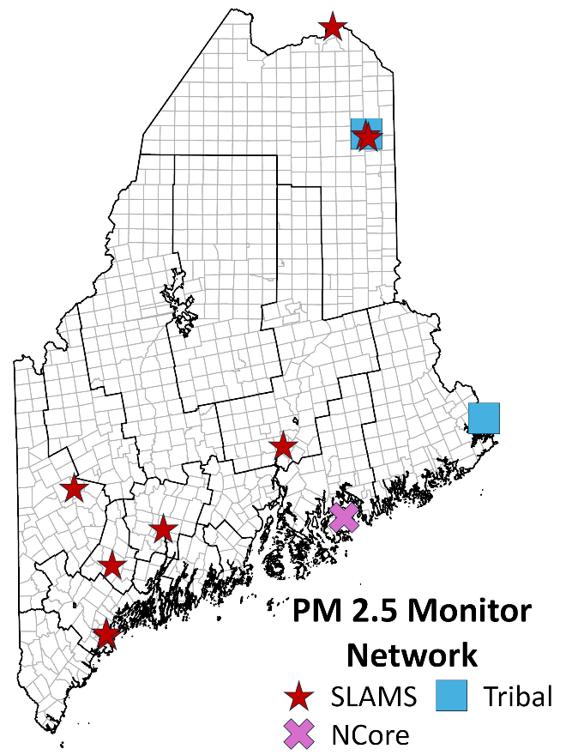
PM_{2.5} Network
In 1999 the Maine DEP began a PM_{2.5} monitoring program using filter-based samplers that met the federal reference method (FRM) requirements. The network began with 15 sites starting up during the first year of operation. Three years of data collection demonstrated compliance with the PM_{2.5} standard at all monitoring sites, after which some of the samplers were relocated or reconfigured to collect PM₁₀ samples. In 2000, DEP procured a few continuous FEM monitors, TEOMs (tapered element oscillating microbalance), for continuous PM_{2.5} monitoring. The TEOMs were later replaced starting in 2013 with FEM BAMs (beta attenuation monitors), which were installed at existing PM_{2.5} monitoring stations (collocated beside the FRM samplers) to provide near real-time data for forecasters.
Starting in January of 2020, DEP started to shut down many FRM samplers that were collocated with FEM continuous samplers as a cost reduction. Starting in January 2023, many of the BAMs were replaced with a newer continuous instrument, the T640x, that measured both continuous PM_{2.5} and PM₁₀ simultaneously. Currently, DEP maintains 10 PM_{2.5} monitoring locations, all with continuous monitors. Four PM_{2.5} monitoring sites have collocated FRM samplers to act as quality control and assurance monitors, and a fifth site, the NCore site in Bar Harbor, also has FRM samplers due to NCore requirements, but the location and siting of the instruments does not condone use as a quality control and assurance monitor per EPA siting requirements. Maine Tribes operate two continuous FEM monitors in Presque Isle and Pleasant Point.
All of the current sites continue to comply with the PM_{2.5} standard and remain in operation to gather trend data, document future attainment status, and forecast ambient air quality. The continuous, hourly averaged PM_{2.5} records are reported in near real-time to both the Maine DEP web page and the EPA AirNow web site.
DEP has chosen to operate two continuous monitors at the Presque Isle Riverside station. Maintaining the older BAM and the new T640x monitors allows forecasters to learn how the different monitors respond to the springtime road dust events that cause elevated PM in downtown Presque Isle. The BAM was expected to be removed in August 2023; however, the DEP saw value in extending the continued operation of the BAM. The BAM has swapped between sampling for PM₁₀ as a springtime road dust comparison, and PM_{2.5} as a summertime woodsmoke comparison. Due to operational trouble with the newer T640x instruments, when the Riverside shelter is replaced in the summer of 2026, the T640x will not be reinstalled. Instead, the DEP will return to operating and maintaining two BAMs (PM_{2.5} and PM ₁₀) and one FRM sampler at this location. At the Presque Isle – Regional Office site, the T640x will also be replaced with a BAM. The two T640x monitors will be reserved as operational spare units to be used to maintain the rest of the T640x network.
In the City of Portland, due to an expansion of a walk and bike path, DEP had to remove the monitoring Dearing Oaks Park station in August 2025. Working with the City of Portland, a suitable replacement location was identified on Thames Street near the Ocean Gateway cruise ship terminal building. This location is also immediately adjacent (20 feet) to an existing long-term SPM site, as part of the South Portland - Portland HAPs study. The existing SPM HAPs monitoring equipment was merged into the new monitoring station. The new location has several nearby sources, and topography will funnel emissions from the downtown Portland and South Portland areas toward the monitoring location for significant parts of the year. The Ocean Gateway station came online in January of 2026, with the continuous monitor coming online in May 2026.
In January 2025, the Maine DEP expanded the Rumford Intra-valley Transport Analysis (RITA) project to determine if the current location of the Rumford monitoring station is in the ideal location for particulate monitoring for the Rumford and Mexico community. This study was expanded again in October and November of 2025, with an expectation to be reduced in the fall of 2026. Upon reviewing the expanded RITA project data, the DEP may consider moving from the current Rumford monitoring site in the summer of 2027. (Additional information on the RITA project can be found under Monitoring Projects and Air Quality Studies on page 41.)
The Mi’kmaq Nation shut down their Northern Drive monitoring station in the fall of 2025, while the new shelter was prepared. The new location is located about 1,000ft to the northeast. PM_{2.5} monitoring is expected to resume in the spring of 2026 in the new location.
Proposed changes for the PM_{2.5} network:
- Install a Teledyne T640x instrument in Lewiston, located with the current Met One BAM 1020 and planned filter-based sampler for a minimum of 1-year, longer if required. Replace the current Lewiston shelter with a new shelter that will be in an adjacent parking spot. Downtime is expected to be minimal.
- The Maine DEP is considering moving the current Rumford monitoring station to another location within the Rumford and Mexico community. A decision will not be made prior to November 2026, and no changes are likely to occur prior to summer 2027.
- Security has been an on-going issue at the Portland Tukey’s Bridge Site. DEP has been unable to find a contractor willing to install a security fence at this location that would not extend outside of our existing footprint. Additionally, Maine Department of Transportation (DOT) is planning to create an additional exit lane to provide direct access to the new Roux Institute campus. Depending on where the new exit lane begins, this station may be forced to shut down. Draft plans for the new exit lane do not impact the monitoring site.
- The T640x at Presque Isle – Regional Office will be replaced with a BAM so that the T640x instrument can be maintained as an operational spare considering the operational difficulties with those instruments.
- The shelter at Presque Isle Riverside will be replaced during the summer of 2026. The current shelter and all instruments will be removed so the new shelter can be reinstalled in the same location. There may be significant down time associated with this move. The T640x will not be reinstalled in the new shelter. Instead, the primary monitor will return to being a BAM, with a collocated FRM sampler. A second BAM will monitor for PM₁₀.
PM_{2.5} Monitoring Site Summary
PM_{2.5} Monitoring Site | Site Type | Monitoring Objective | Sampling Method and Frequency
Augusta – Lincoln Street School | SLAMS | 200K Pop Coverage/AQI Forecasting/Mapping¹ | FEM³, Continuous
Bangor – Mary Snow School | SLAMS | 200K Pop Coverage/AQI Forecasting/Mapping¹ | FEM⁴, Continuous
Bangor – Mary Snow School | SLAMS | QA-Collocation | FRM², every 6 days
Bar Harbor – McFarland Hill | NCore | Transport | FRM², every 3 days
Bar Harbor – McFarland Hill | NCore | Mapping | FEM³, Continuous
Lewiston – Country Kitchen Lot | SLAMS | 200K Pop. Coverage/ Mapping¹ | FEM⁴, Continuous
Lewiston – Country Kitchen Lot | SLAMS | QA-Collocation | FRM², every 6 days
Lewiston – Country Kitchen Lot | SLAMS | 200K Pop. Coverage/ Mapping¹ | FEM³, Continuous
Madawaska – Public Safety Bldg. | SLAMS | High Pop. Exposure/ AQI Forecasting/Mapping | FEM³, Continuous
Perry – Pleasant Point/Sipayik | Tribal | Mapping | FEM⁴, Continuous
Portland – Ocean Gateway | SLAMS | MSA of 200-500K | FEM³, Continuous
Portland – Ocean Gateway | SLAMS | QA-Collocation | FRM², every 6 days
Portland – Tukey’s Bridge | SLAMS | High Traffic | FEM³, Continuous
Presque Isle – Skypot Drive | Tribal | Mapping | FEM³, Continuous
Presque Isle – Regional Office | SLAMS | Background | FEM⁴, Continuous
Presque Isle – Riverside Street | SLAMS | 200K Pop Coverage/AQI Forecasting/Mapping¹ | FEM⁴, Continuous
Presque Isle – Riverside Street | SLAMS | QA-Collocation | FRM², every 6 days
Rumford – Rumford Avenue | SLAMS | High Pop. Exposure/ AQI Forecasting/Mapping¹ | FEM³ Continuous
1 – 200K Pop. – 200,000 Population; AQI – Air Quality Index; MSA – Metropolitan Statistical Area
2 – Monitor method: RFPS-1006-143: Thermo-Fisher Scientific Model 2000i
3 – Monitor method EQPM–0516 –238: Teledyne Model T640x
4 – Monitor method: EQPM – 0308-170: Met One Instruments Model 1020 BAM

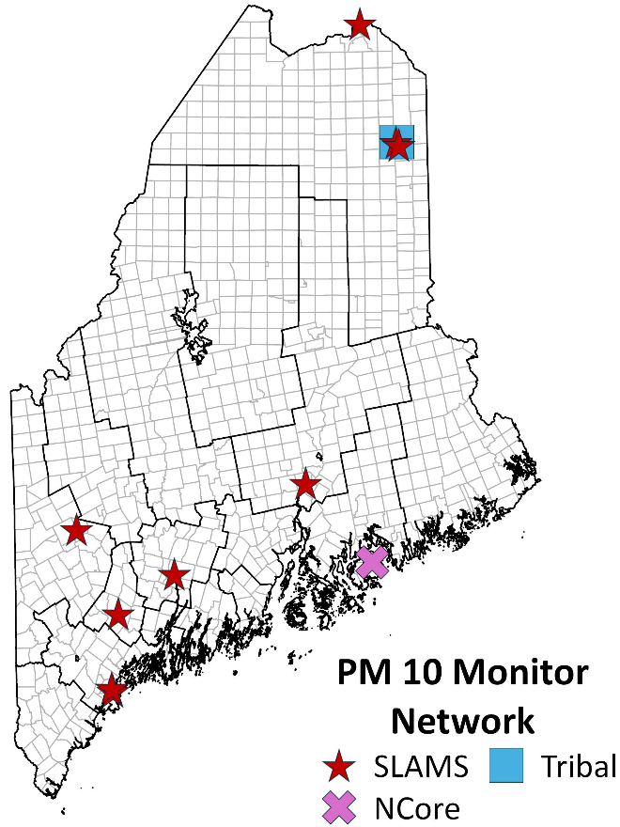
PM₁₀ Network:
Prior to the end of 2022, the Maine DEP met most of the PM₁₀ sampling needs using FRM filter-based samplers. A continuous Beta Attenuated Monitor (BAM) was operated in Presque Isle as part of the control strategy for the historically high PM₁₀ levels there. After a PM₁₀ exceedance of the NAAQS on August 12, 2018, a second BAM for PM₁₀ was installed in Madawaska at the Public Safety building in 2020 to assess the potential frequency of the exceedances more accurately, document compliance with the NAAQS, and allow for daily averages.
In January 2023, DEP procured several new monitors capable of measuring continuous PM_{2.5} and PM₁₀ simultaneously. These new monitors made the FRM samplers at many sites redundant. Most of the PM₁₀ FRM samplers were shut down by the end of 2023, and all remaining FRM samplers were shut down June 30th, 2024.
When the Riverside shelter is replaced in the summer of 2026, the T640x will not be reinstalled. A BAM will be the permanent PM₁₀ monitor. At the Presque Isle – Regional Office site, the T640x will be replaced with a single BAM only measuring PM_{2.5}, ending the PM₁₀ monitoring at this site. These changes are so that those T640x instruments can be reserved as operational spares due to operational trouble presented by T640x instruments.
Proposed changes to the PM₁₀ Network:
- Replace the current Lewiston shelter with a new shelter that will be in an adjacent parking spot. Downtime due to the shelter exchange is expected to be minimal.
- PM₁₀ monitoring at Presque Isle – Regional Office will conclude.
- A security fence will be installed around our platform at Portland Tukey’s Bridge.
PM₁₀ Monitoring Site Summary
PM₁₀ Monitoring Site Address | Site Type | Monitoring Objective | Sampling Method¹
Augusta – Lincoln Street School | SLAMS | Attainment/Nonattainment | T640x²
Bangor – Mary Snow Elementary School | SLAMS | Attainment/Nonattainment | T640x²
Bar Harbor – McFarland Hill | NCore | Rural Background | T640x²
Lewiston – Country Kitchen Lot | SLAMS | Attainment/Nonattainment | T640x²
Madawaska – Public Safety Bldg. | SLAMS | Attainment/Nonattainment | T640x²
Portland – Tukey’s Bridge | SLAMS | Attainment/Nonattainment | T640x²
Presque Isle – Riverside Street | SLAMS | Attainment/Nonattainment | BAM^{3,}
Presque Isle – Regional Office | SLAMS | Background | T640x²
Presque Isle – Skypot Drive | Tribal | Mapping | T640x²
Rumford – Rumford Avenue | SLAMS | Population exposure/ AQI Forecasting/Mapping | T640x²
Portland – Ocean Gateway | SPM | MSA of 200-500K | T640x²
- Both methods are continuous FEMs.
- Method EQPM–0516 –239: Teledyne T640x
- Method EQPM-0798-122: Met One BAM 1020

PM_{Coarse} Network:
Required PM_{Coarse} (PM_{10-2.5}) measurements at the NCore site in Bar Harbor are obtained from the Teledyne T640x PM monitor installed in January of 2023. In addition, PM_{10-2.5} data are collected from the other Teledyne T640x instruments in the network but are not reported to AQS.

PM_{Coarse} Monitoring Site Summary
PM_{Coarse} Site Address | Site Type | Monitoring Objective | Sampling Frequency
Bar Harbor – McFarland Hill | NCore | Rural Background | FEM¹, Continuous
- Monitor method EQPM–0516 –240: Teledyne model T640x

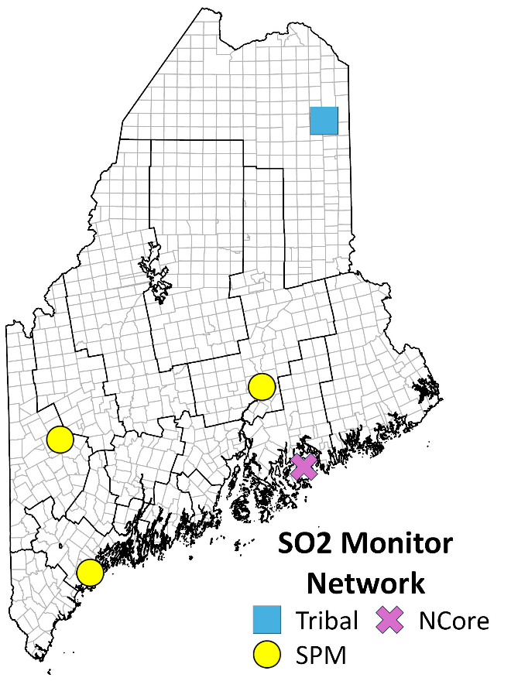
Sulfur Dioxide Network:
The Maine DEP currently operates two trace-level sulfur dioxide (SO₂) monitors, the first at the NCore site in Bar Harbor, the second as a SPM in Portland. The Mi’kmaq Nation operates an SO₂ monitor in Presque Isle that was shut down with the old monitoring location in the fall of 2025 but will resume at the new location in the spring of 2026.
The SO₂ monitor in Portland came online in January 2026 and is planned to be operated for one year. At the end of this year, data will be assessed to determine if there is a need to continue monitoring.
In conjunction with the planned H₂S monitoring project to occur in Old Town and Rumford, the DEP intends to install SPM SO₂ monitors for the duration of the H₂S project at these locations. The SO₂ data may provide additional insight into sources, though the two spare monitors the DEP has for this intention are older, and may not be operated or shut down early if they provide extensive operational difficulties.
Proposed changes to the SO₂ Network:
- The Maine DEP will assess the one-year of SO₂ from Ocean Gateway to determine if there is a need to continue monitoring.
- SPM monitors intended to be installed with H₂S monitors in Old Town and Rumford.
SO₂ Monitoring Site Summary
SO₂ Monitoring Site | Site Type | Monitoring Objective | Sampling Frequency
Bar Harbor – McFarland Hill | NCore | Background | Continuous
Portland – Ocean Gateway | SPM | Maximum Concentration, Urban Background | Continuous
Old Town | SPM | Source appointment | Continuous
Rumford | SPM | Source appointment | Continuous
Presque Isle – Skypot Drive | Tribal | Mapping | Continuous

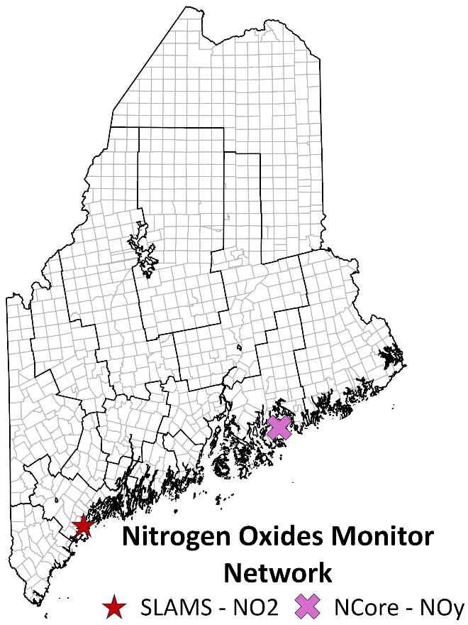
Nitrogen Oxides Network (NO₂, NOx, NO, NOy):
The DEP currently operates one trace-level NO_{x} monitor and one trace-level NO_{y} monitor. The NO_{x} monitor is located at the Portland Ocean Gateway site, replacing the previous Deering Oaks site in Portland. The NO_{y} monitor is located at the NCore site in Bar Harbor. The Mi’kmaq Nation had, until recently, operated a trace-level NO_{x} monitor at their site in Presque Isle, but the monitor, which was far past the monitor’s expected lifespan, stopped functioning and has been shut down unexpectedly. If funding for a replacement monitor can be obtained, the Mi’kmaq Nation may resume trace-level NO_{x} monitoring.
No proposed changes to the Nitrogen Oxides Network.
NO_{X/Y} Monitoring Network Summary
Nitrogen Oxides Network Site Address | Site Type | Monitoring Objective | Sampling Frequency
Portland – Ocean Gateway (NO_{x}) | SLAMs | Maximum Concentration, Urban Background | Continuous
Bar Harbor – McFarland Hill (NO_{y}) | NCore | Transport (trace-level) | Continuous

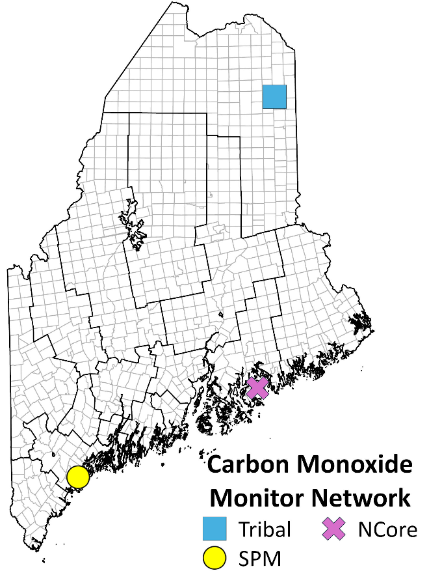
Carbon Monoxide Network:
The DEP currently operates one trace-level carbon monoxide (CO) monitor located at the NCore site in Bar Harbor. The DEP plans to install an SPM CO monitor in Portland for one year to determine if there is a need for continued monitoring. The Mi’kmaq Nation operated one CO monitor at their old monitoring location that was shut down in the fall of 2025, but monitoring is expected to resume in the spring of 2026 at the new monitoring location.
Proposed changes to the Carbon Monoxide Network:
- Replace the CO monitor at McFarland Hill NCore site with a new monitor.
- When one year of monitoring of CO in Portland is completed, the DEP will assess a need to continue to monitor for CO in Portland.
CO Monitoring Network Summary
Carbon Monoxide Site Address | Site Type | Monitoring Objective | Sampling Frequency
Bar Harbor – McFarland Hill | NCore | Transport | Continuous
[Planned]  Portland – Ocean Gateway | SPM | Maximum Concentration, Urban Background | Continuous
Presque Isle – Skypot Drive | Tribal | Mapping | Continuous

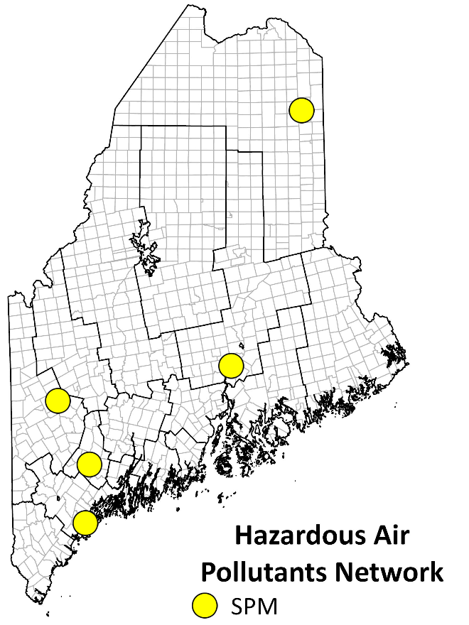
Hazardous Air Pollutants (HAPs) Network:
Although not a required monitoring network, the DEP samples for 67 HAPs compounds at five permanent SPM sites located around the state. The objective of monitoring is to document background HAPs concentrations around the state and to establish whether there are any trends in the levels of these compounds. Maine monitors for most HAPs compounds using EPA Method TO-15.
Mercury, while also a HAP, is sampled as a sub-network part of the atmospheric deposition network discussed on page 32, more details about the mercury sampling can be found there.
The Maine DEP also has several shorter-term SPM HAPs samplers throughout the state. More information on this can be found below in the Monitoring Projects and Air Quality Studies on page 35.
The Presque Isle Riverside shelter will be replaced in the summer of 2026 that may cause some extended downtime with sampling.
Proposed changes to the HAPs monitoring Network:
- Several short-term SPM HAPs sites in Portland and South Portland may be shut down. These sites far outlived their expected lifespan.
HAPS Monitoring Site Summary
Site Address | Site Type | Monitoring Objective | Sampling Frequency
Bangor – Mary Snow School | SPM | Maximum Conc.& Trends | Every 6 days
Lewiston – Country Kitchen Lot | SPM | Maximum Conc.& Trends | Every 6 days
Presque Isle – Riverside Street | SPM | Maximum Conc.& Trends | Every 6 days
Rumford – Rumford Avenue | SPM | Maximum Conc.& Trends | Every 6 days
Portland – Ocean Gateway | SPM | Maximum Conc.& Trends, Quality assurance related collocated sampling | Every 6 days

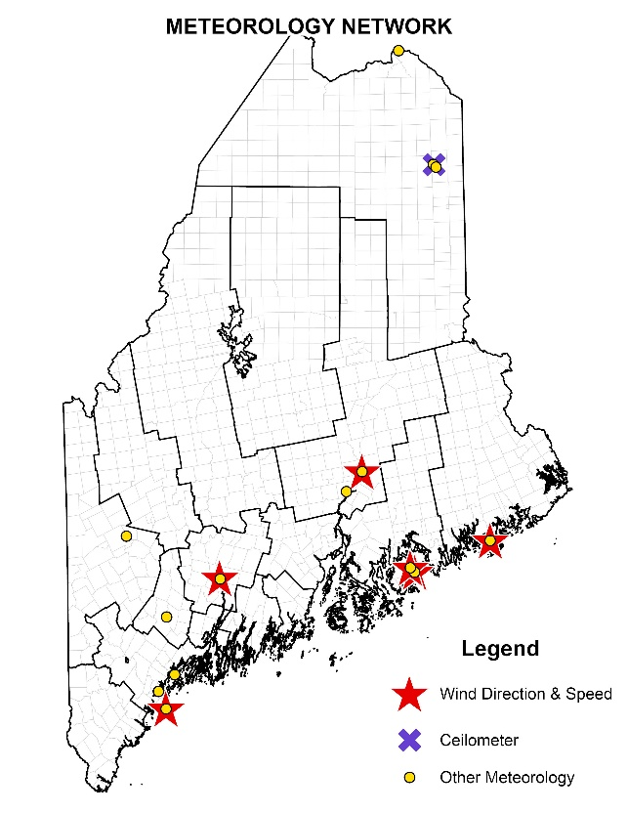
Meteorological Network:
The DEP operates and maintains year-round and seasonal meteorological monitoring stations across the state measuring parameters such as wind speed and direction, solar and UV-B radiation, ambient temperature, barometric pressure, and relative humidity.
Department air quality forecasters also have access to data from airport stations and other sites located throughout the state. Airport sites have a mix of data availability and reliability, making data from the DEP sites more desirable.
The wind speed and direction sensors installed with the Cadillac Mtn. and Jonesport ozone monitors augment the ozone measured at those sites. Additionally, Cape Elizabeth is part of Maine’s EMP network. As part of the EMP plan, Maine monitors a variety of meteorological parameters to assist with forecasting and photochemical assessments.
The Bar Harbor McFarland Hill monitoring location is part of the NCore and CASTNET networks. Both networks require several meteorological parameters to be recorded at the station and reported to AQS.
Ambient temperature and pressure are recorded at particulate monitoring stations. This data is required for the particulate monitors to control air flow through the particulate size selective stages to ensure that correct fractional size is being measured. Historically, there was a requirement to submit these data, and while this is no longer true, the DEP does find value in these data and does continue to submit these data to AQS. Starting January 2024, the DEP switched from submitting the 24-hour temperature and pressure data from the FRM PM samplers, to submitting the continuous one-hour temperature and pressure data from the FEM samplers.
In 2021, the monitors at the Passamaquoddy site in Sipayik were moved to a new shelter; however, the meteorological tower and equipment have not been moved yet.
In fall 2022, the DEP removed the ozone and meteorological equipment from the Jonesport Public Landing building in preparation for the building being demolished. In spring 2023, the DEP moved this monitoring station to the Jonesport Coast Guard station, about one mile to the east-southeast. This location has excellent fetch for wind speed and direction, and the DEP was requested to monitor wind parameters year-round for at least five continuous years to provide a source of weather modeling data.
The DEP operates a UV-B monitoring station for the Colorado State University UV-B Monitoring and Research Program at the Presque Isle background station.
The DEP operates several lower-cost meteorological sensors. These sensors do not meet the requirements for AQS-quality data and are not used outside of this study. More information on these stations can be found in the Monitoring Projects and Air Quality Studies on page 35.
Proposed changes to the Meteorological Network:
- Install a ceilometer at the Presque Isle Riverside site.
- Install a wind speed and direction sensor at Ocean Gateway
Meteorology Monitoring Site Summary
Site Address | Site  Type | Monitoring Objective | Monitored Parameters and  Seasonality* if applicable
Augusta  State Airport | N/A | Data Analyses & Modeling | Wind speed and direction
Augusta  Lincoln Street School | N/A | Data Analyses | Temperature and barometric pressure
Bangor  Mary Snow School | N/A | Data Analyses | Temperature and barometric pressure
Bar Harbor  Cadillac Mountain | N/A | Transport | Wind speed and direction, temperature, and relative humidity  *Seasonal only
Bar Harbor  McFarland Hill | NCore & CASTNET | Transport | Wind speed and direction, temperature, barometric pressure, relative humidity, and solar radiation
Cape Elizabeth  Two Lights Park | EMP | Transport | Wind speed and direction, temperature, barometric pressure, relative humidity, and solar and UV-B radiation  *Wind Seasonal only
Jonesport  Coast Guard Station | EMP | Data Analyses & Transport | Wind speed and direction, temperature, and relative humidity
Lewiston  Country Kitchen Parking | N/A | Data Analyses | Temperature and barometric pressure
Madawaska  Public Safety Building | N/A | Data Analyses | Temperature and barometric pressure
Old Town  Global Secure Shipping | SPM | Data Analyses | Wind speed and direction, temperature, and relative humidity
Presque Isle  Background Site | SPM | Data Analyses | Temperature and barometric pressure.  UV-B radiation for the University of Colorado
Presque Isle  Riverside | N/A | Data Analyses | Temperature and barometric pressure
Portland Ocean Gateway | N/A | Data Analyses | Wind speed and direction, temperature, and relative humidity
Rumford  Rumford Avenue Parking | N/A | Localized Wind & Data Analyses | Temperature and barometric pressure. Wind speed and direction at 5 m above ground.

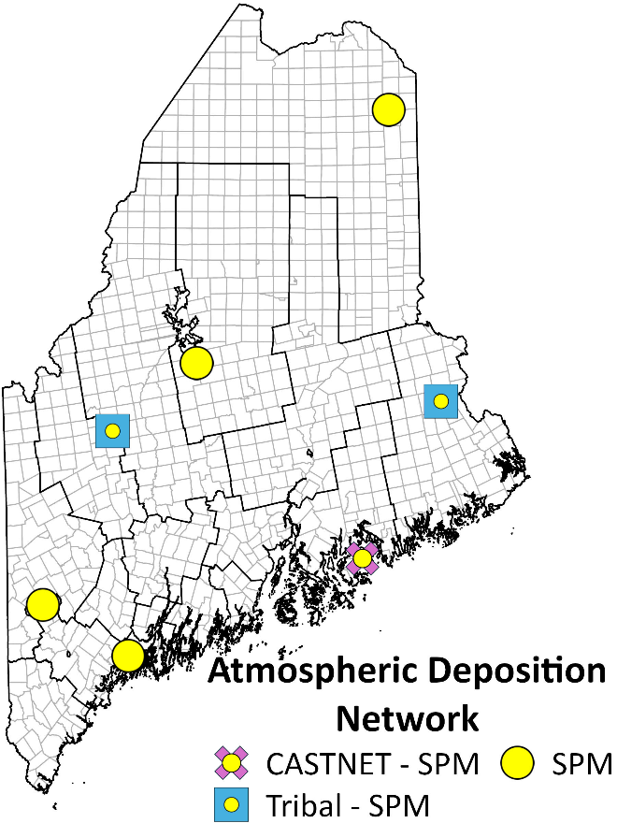
Atmospheric Deposition Network:
There are seven National Atmospheric Deposition Program (NADP) sites in Maine, five operated by the Maine DEP, with the remaining two operated by tribal operators. NADP oversees five national deposition networks, two of such networks are operated in Maine.
The National Trends Network (NTN) analyzes precipitation for several chemical ions, these ions can cause the precipitation to be acidic (i.e., acid rain). NTN samplers are collected at all seven NADP sites in Maine.
The Mercury Deposition Network (MDN) analyzes precipitation for mercury. All seven NADP sites collect MDN samples.
The NADP also oversee the PFAS-NTN Subnetwork (PFN). This is a subnetwork as part of the NTN network, where excess precipitation from the NTN sample is analyzed for Per- and polyfluoroalkyl substances (PFAS). Maine operates one PFN site in Freeport, funding for this location is sponsored by the EPA, and continued funding for this sponsorship is uncertain.
The MDN and NTN data are valuable to DEP data users, policy makers, the public, and to various users representing many scientific disciplines: wildlife biologists, water quality specialists, epidemiologists, atmospheric chemists, government regulators, and academic researchers.
Deposition Monitoring Site Summary
Site Address and NADP ID | Site Type | Monitoring Objective | Sampling Frequency
Bar Harbor – McFarland Hill (NTN and MDN) ME98 | CASTNET & SPM | Transport/Trends | Weekly Composite
Bridgton – Upper Ridge Road  (NTN and MDN) ME02 | SPM | Transport/Trends | Weekly Composite
Caribou – Airport (NTN and MDN) ME00 | SPM | Transport/Trends | Weekly Composite
Carrabassett Valley – Airport (NTN and MDN) ME04 | Tribal | Transport/Trends | Weekly Composite
Freeport – Wolfe’s Neck Farm (NTN, PFN and MDN) ME96 | SPM | Transport/Trends | Weekly Composite
Greenville Station (NTN and MDN) ME09 | SPM | Transport/Trends | Weekly Composite
Indian Township (NTN and MDN) ME94  (Non – PQAO location) | Tribal | Transport/Trends | Weekly Composite

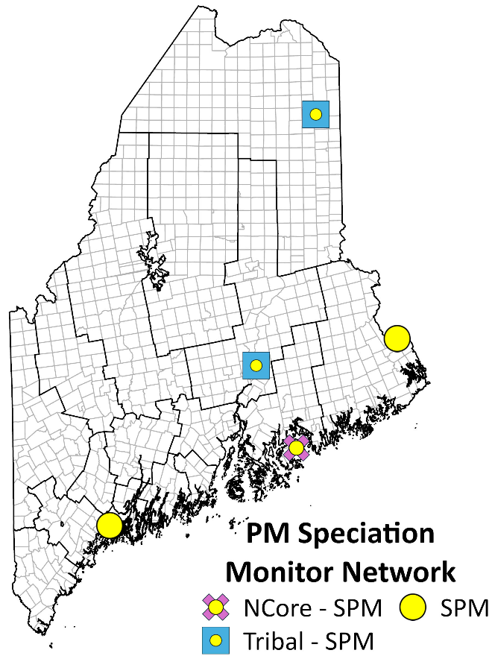
PM Speciation Network (IMPROVE):
Many stunning and breathtaking vistas at National Parks and Wilderness Areas may be lost or diminished due to the haze formed by air pollutants. These light scattering hazes cause discoloration, loss of texture, and reduced visual range. Recognizing the importance of visual air quality, Congress included legislation in the Clean Air Act to prevent and remedy visibility impairment. To aid in the implementation of this legislation, the Interagency Monitoring of Protected Visual Environments (IMPROVE) program was initiated in 1985. The Maine DEP operates one IMPROVE site in Freeport, Maine at Wolfe’s Neck Farm. The NPS operates an IMPROVE site in Maine’s designated Class 1 visibility area in Acadia National Park. The US Fish and Wildlife Service operates an IMPROVE site in Maine’s designated Class 1 visibility area in the Moosehorn National Wildlife Refuge in Baring. IMPROVE sites are also operated by the Penobscot and Mi’kmaq Nation on Indian Island and in Presque Isle, respectively.
IMPROVE Network Summary
IMPROVE Site Address | Site Type | Monitoring Objective | Sampling Frequency
Bar Harbor – McFarland Hill | SPM/NCore | Regional Haze | Every 3 days
Freeport – Wolfe’s Neck Road | SPM | Deposition Project | Every 3 days
Indian Island – Penobscot | Tribal | Regional Haze | Every 3 days
Baring – Moosehorn National Wildlife Refuge | SPM | Regional Haze | Every 3 days
Presque Isle – 8 Northern Road | Tribal | Regional Haze | Every 3 days

Lead Network:
In 2008, EPA promulgated a lead (Pb) standard and issued some minimum monitoring requirements to the states. At that time, the Maine DEP was going to be required to operate one Pb monitor in the Portland Core-based statistical area (CBSA). The state purchased an X-ray fluorescence (XRF) analyzer to measure lead concentrations from PM₁₀ filters. The EPA Pb requirement was subsequently revised to require Pb monitoring at urban NCore sites only. The Bar Harbor NCore site is designated as a rural site, so there is no requirement for Pb monitoring in Maine. The PM speciation network, IMPROVE (above) does have lead as a monitored pollutant, though not complaint to NAAQS standards.
The Maine DEP maintained the capability and capacity to analyze particulate filters for Pb and other several other metals that are listed as HAPs, such as arsenic and chromium until 2024. The department still owns the XRF analyzer; however, a critical part of the analyzer failed, and repairing this instrument would require a significant investment by the DEP.

Monitoring Projects and Air Quality Studies:
The purpose of monitoring projects and air quality studies is to assess the health risks to the public in areas with localized air quality concerns or that do not fall within the scope of the criteria pollutants with a NAAQS. These projects typically involve spatial scales of neighborhood size or smaller. These projects and studies may have a wide range of pollutants associated with the project, and the Maine DEP relies on multiple methods to conduct the monitoring, including the use of low-cost sensors. Due to their low cost and ease of operation, these sensors are widely used by private citizens, researchers, and public entities. The data from these sensors may be used to estimate health risk; however, it is important to note that these sensors are not regulatory monitors and do not have a Federal Reference Method (FRM) or Federal Equivalent Method (FEM) designation. Without FRM or FEM destination, these sensors may not be used for compliance and enforcement actions and may not be submitted to the EPA Air Quality System. These devices may be used to supplement regulatory monitoring, as a screening tool to determine the need for regulatory monitoring, or as part of an air quality study that does not require regulatory monitoring. Sensors may be collocated with regulatory monitors as a tool to provide validation to the sensors’ functionality and accuracy. Sensor manufacturers, the EPA, and researchers also benefit from collocated data and have developed better sensor pollutant calculation formulations and corrections over time as more data become available. The sensors used by the Maine DEP may be removed and/or set up in new locations on an as needed basis and are subject to change with little or no notice. The brand of low-cost sensors and their measurable parameter(s) used by the Maine DEP are outlined in the projects below. The use of a certain sensor by the Maine DEP does not constitute a promotion of that sensor or the brand of sensor.

South Portland/Portland VOC Monitoring Project:
At the request of South Portland City officials, on April 16, 2019, DEP staff attended a City Council public workshop focused on citizen concerns about odors and air emissions coming from bulk petroleum storage facilities in the city. One request that was repeatedly expressed by the residents who spoke was the very strong desire for air quality monitoring to be conducted within South Portland's boundaries, since none had been done since the early 2000s. The DEP made a commitment at the workshop that it would work with South Portland to accomplish that goal. On August 28, 2019, officials from the City of Portland formally communicated identical air quality concerns from their citizens about the same VOC sources in South Portland. Since then, Air Bureau staff have collaborated with officials from both cities and other local partners to conduct an ambient air quality monitoring project, where the monitoring objective is to collect data to assess ambient levels of VOCs in the area.
The focus of the monitoring project is to measure VOCs, since they constitute a large majority of the compounds associated with the types of odors being reported, as well as air emissions that come from the facilities of concern. VOCs were also chosen because that type of measurement is one that the Air Bureau air monitoring program was already capable of supporting.
Phase 1 and 2:
In calendar year 2019, the project consisted of two phases: 1) an early "grab sampling" effort in South Portland, and 2) a network of eight fixed 24-hour sampling sites (five in South Portland and three in Portland). The grab sampling phase was launched on June 10, 2019, and concluded on September 15, 2019. By November 1, 2019, all planned 24-hour sampling sites were established and samples were collected on a frequency of one sample every six days. By city request, the sites in South Portland were placed so that each of the five voting districts had a sampler established within their boundary.
Fixed 24-hour sampling sites were established at: Bug Light Park in South Portland; the South Portland City Assessor’s office; South Portland High School; South Portland School Administration building; Red Bank Community Center in South Portland; Ocean Gateway building in Portland; and on West Commercial Street in Portland. The two new monitoring sites in Portland augment data from the DEP’s site at Deering Oaks Park.
Phase 3 – Portable Sampling and Meteorological data:
During calendar year 2020, the implementation of phase 3 began, which included the deployment of a portable sampling platform. The platform initially had both a canister sampling system for measuring VOCs (identical to ones used at the fixed 24-hour sampling sites), and a tube sampling system for measuring Polycyclic Aromatic Hydrocarbons (PAHs). A continuous low-cost particulate matter sensor was added in 2021. Since the platform can easily be moved from one location to another, it allowed 24-hour samples to be taken at a number of additional places early in the program. This data helped improve the overall spatial and temporal understanding of air quality in the project area. The first deployment of the platform took place at the end of August 2020 and continued through 2021. In September 2021, the platform was established at the Cash Corner Fire Station.
2020 also saw the addition of meteorological stations added to the fixed HAPs monitoring sites. Starting with the Assessor’s Office and Deering Oaks sites in June, and expanding to Ocean Gateway, West Commercial, Bug Light, and Mechanic St. though the rest of 2020 and into 2021. Operational difficulties with the equipment at the Assessor’s Office, compounded by difficult site access to the roof where the meteorological station was located, prompted an early end to meteorological data collection at that site. The Bug Light meteorological station was shut down with the site in 2024, and all remaining were shut down in 2025.
Phase 4 – Network Reevaluations:
After the first full year of concurrent 24-hour sampling at all the VOC sites in the project’s monitoring network, the DEP informed officials in both cities that it intended to extend its support of the project’s monitoring activities through 2021. The DEP had originally committed to running these sites for one full year from the network completion date; that is, until November 2020.
The DEP informed the cities that they would routinely reevaluate the network and adjust the use of resources to as needed. The first evaluating came in March 2021, with the shutdown of the School Administration building, with those resources reallocated to Mechanic St. The DEP and the City of South Portland have routinely discussed the network and reevaluations.
Phase 5:
During a network evaluation in the summer of 2023 precipitated by reduced staff availability in Southern Maine, the department planned to shut down the South Portland High School location. The City of South Portland and residents requested that the High School sampler be moved to Pearl St., a former portable sampling platform location, and that the Bug Light sampler be installed on Front St. The DEP agreed on the condition that the City maintained these sites and sample exchanges.
Fenceline VOC monitoring in South Portland (not conducted by ME DEP):
Fenceline monitoring using the EPA method 325A & B, became a statewide requirement for bulk petroleum facilities starting in 2024 under Maine DEP Chapter 171. The facilities in South Portland each have a network of 12-18 sampling locations that are used to collect consecutive 14-day passive samples. The size of the network is dependent on the size, shape and design of each facility to maintain a minimum density of sampling locations. The DEP reviews the results of the fenceline monitoring but does not partake in the sampling or analysis.
Continuous Total VOC monitoring
In 2022, low-cost continuous VOC sensors capable of low-level and ambient VOC detection became commercially available. DEP purchased a SENSIT SPOD for the measurement of total VOC in 2023 and installed it at a Central Maine HAPs monitoring site to determine comparability to the HAPs can results. The SPOD was later moved to Mechanic St. in early 2024 to continue the comparability assessment. Initial results were very poor, but after lengthy troubleshooting with the vendor, the issues were resolved near the end of fall 2024.
In response to continued concerns of South Portland residents and the recent availability of equipment that could be loaned from the EPA, the DEP agreed to conduct a one-year study using SPODs to provide supplemental information on short-term variability (e.g., hour-to-hour differences) of total VOC concentrations that cannot be quantified using the 24-hour HAPs can samples or 14-day fenceline samples.
In addition to the one SPOD owned by the DEP, three SPODs were borrowed from the EPA to conduct a 12-month deployment of continuous total VOC monitoring in the communities abutting the bulk petroleum facilities, from November 2025 to November 2026. Three pre-existing VOC monitoring locations near facilities were chosen to host SPODs, Mechanic St., Front St., and Pearl St. A fourth location, Red Bank was chosen to act as an urban background to provide comparative baseline information to the others, and this location was determined to be of least priority, meaning that the SPOD would be used at any of the other three locations if the SPODs at those locations required repair and an extended downtime is expected. Upon reviewing the Red Bank location, there were both safety and security concerns for staff and equipment, and an alternative location 800 ft to the west at the Western Avenue Fire Station was chosen.
In March of 2026, upon preliminary review of the first year of fenceline monitoring data, the DEP determined additional information near Lincoln St. would be useful. DEP worked with the City of Portland to find a suitable location for an SPOD in the Forest City Cemetery near Lincoln St. DEP moved the Western Ave. SPOD to this new location in March, and are looking to acquire a replacement SPOD for Western Ave.
The following is a list of network changes since November 2019, in chronological order:
- August 2020: launch of the portable sampling platform.
- March 2021: the South Portland School Administration site was shut down. Resources from this site were moved to the new Mechanic St. site.
- September 2021: Due to reduced staff availability with the conclusion of a 1-year term AmeriCorps volunteer, the portable sampling platform was installed at the South Portland Cash Corner Fire Station.
- June 2022: Assessor’s Office shut down.
- September 2022: Cash Corner formally became a network site. Officially discontinued plans to renew portable sampling.
- October 2023: High School shut down and Pearl St. came online.
- Spring 2024: a SPOD was added to Mechanic Street. This was used as a testing location so that DEP could assess the capabilities of this type of sensor for future uses.
- Summer 2024: Front St. came online (May) and Bug Light shut down (July).
- Summer and Fall 2024: facility fenceline monitoring began.
- August 2025: Deering Oaks Park monitoring site shut down.
- November 2025: SPODs were installed at the Front and Pearl St. HAPs sampling locations.
- January 2026: an SPOD was installed at the South Portland Western Ave. Fire Station.
- March 2026: Western Ave. SPOD moved to the Forest City Cemetery.
Proposed changes to the South Portland/Portland VOC network:
- Upon the release of the six-year report from the Maine CDC concerning the results of HAPs TO-15 analysis, the DEP plans to scale back the canister-based monitoring in South Portland and Portland.
- The continuous total VOC monitoring project will conclude in November 2026. SPODs will return to Mechanic St. for a post-study collocation for 4-weeks and EPA owned equipment will be returned to the EPA.
South Portland/Portland VOC Monitoring Sites
Site Address | Site Type | Monitoring Objective | Sampling Frequency
So. Portland – Redbank Community Ctr | SPM | Max Conc.& Population Exposure | Every 6 days
So. Portland – Mechanic Street | SPM | Max Conc.& Population Exposure | Every 6 days
So. Portland – Cash Corner Fire Station | SPM | Max Conc.& Population Exposure | Every 6 days
Portland – Ocean Gateway¹ | SPM | Max Conc.& Population Exposure | Every 6 days
Portland – West Commercial Street | SPM | Max Conc.& Population Exposure | Every 6 days
So. Portland – Pearl St.² | SPM | Max Conc.& Population Exposure | Every 6 days
So. Portland – Front St. ² | SPM | Max Conc.& Population Exposure | Every 6 days
So. Portland – Mechanic Street  [SPOD] | N/A | Supplemental Information | Continuous, hourly
So. Portland – Pearl St.²  [SPOD] | N/A | Supplemental Information | Continuous, hourly
So. Portland – Front St. ²  [SPOD] | N/A | Supplemental Information | Continuous, hourly
So. Portland – Western Ave.  [SPOD] | N/A | Supplemental Information | Continuous, hourly
So. Portland – Forest City Cemetery [SPOD] | N/A | Supplemental Information | Continuous, hourly
1 - This site is part of the permanent DEP network.
2 - Denotes that sampler is serviced by people who are not affiliated, or staffed by the DEP

Hydrogen Sulfide:
Over the last several years, the general public’s awareness of how local air pollution affects their neighborhood has increased interest in expanded air quality monitoring at the community level. As part of this interest, hydrogen sulfide (H₂S) has become a top public of concern in Maine, with numerous complaints coming from the Old Town and Rumford, Maine communities. The State of Maine has a chronic Ambient Air Guideline (AAG) for H₂S of 1 ppb for a one-year annual average, and an acute AAG of 30 ppb for a 30-minute average.
In 2023, through a Clean Air Act Grants Under the Inflation Reduction Act, the Maine DEP was able to receive funds to obtain a cavity ring down spectrometry (CRDS) instrument capable of measurement H₂S directly, instead of the traditional thermal decomposition into SO₂ method. The CRDS method is advertised to be highly accurate with very long-term stability. Additionally, the instrument measures a large array of pollutants, which would have allowed the instrument to become a primary tool in many projects throughout the state for years to come. However, this instrument, despite a lengthy troubleshooting process failed to perform as advertised, was returned to the manufacture in 2025. The DEP is currently in the process of obtaining two instruments that use the traditional thermal decomposition method (Teledyne N101) so that the department can conclude the grant requirements within the grant period.
In November of 2023, the Maine DEP installed a HAPs and PM sensor on a property north of the Juniper Ridge landfill (JRL). In the summer of 2026, an H₂S monitor will be installed at a property south of JRL, the Hidden Meadows Golf Course (JRHM), and the second will be installed at the Rumford Avenue parking (RAP) monitoring station. Both locations will also have an SO₂ monitor; however, these monitors are ‘as available’ and may be removed or shut down dependent on needs for the monitors elsewhere in the state.
Proposed changes to the hydrogen sulfide monitoring network:
- H₂S and SO₂ monitors will be installed at both JRHM and RAP monitoring sites.

Aeroallergens:
As part of a Building Resilience Against Climate Effects (BRACE) grant from the US CDC, the Maine CDC received funding to initiate pollen monitoring with the development of a state-wide network. The Maine CDC invited the Maine DEP to be a partner on the project and created a Pollen Advisory Group (PAG) that included an allergist and specialists in climate sciences and meteorology. With funding received from the BRACE grant, the state was able to purchase five continuous pollen samplers, the Pollen Sense APS-400 series, and two rotorod pollen samplers. The rotorods are considered the ‘traditional method’ of pollen monitoring. The primary purpose of this project is to create historical trends over time and to determine any observed impact resulting from climate change. The data from these sensors are also to be used as part of a health alert network, allowing Maine to forecast high allergen days to the public. The DEP deployed four of the APS-400 samplers at separate locations in Maine, providing the best coverage to populations determined to be sensitive to allergens, providing maximum population coverage, and providing maximum geographical coverage. Both rotorod units are collocated with an APS-400 sampler to provide an additional layer of quality control over the new continuous units. The DEP uses the fifth APS-400 sampler for a two-fold purpose: first, as a dedicated spare to be used in the event that one of the other four samplers has operational issues; second, as a ‘floater’ sampler that will be used to determine the spatial representation of the APS-400 samplers. In addition to the state’s efforts, the Mi’kmaq Nation has operated a rotorod sampler in Presque Isle and has recently added a Pollen Sense APS-400.
Site Address | Monitoring Objective | Sampling Frequency
Cape Elizabeth – Two Lights Park | BRACE Grant – Aeroallergen monitoring | Continuous
Bangor – Mary Snow School | BRACE Grant – Aeroallergen monitoring | Continuous
Rumford – Rumford Avenue | BRACE Grant – Aeroallergen monitoring | Continuous
Presque Isle – 8 Northern Road | - | Continuous
Augusta – Viles Arboretum | BRACE Grant – Aeroallergen monitoring | Continuous
Presque Isle – 8 Northern Road | - | 24hr – weekdays*
Augusta – Viles Arboretum | BRACE Grant – Aeroallergen monitoring | 24hr – weekdays*
Aeroallergen Monitoring Sites
* The rotorod requires daily sample collection media changes and cannot be completed when staff are unavailable. Because of this, there may only be four to five samples every week.

Cassidy Point:
The Maine DEP has been working with community members impacted by fugitive dust emissions from a coal storage pile on Cassidy Point in Portland, Maine. In June of 2023, in response to a series of air quality concerns expressed by the public, the DEP Air Licensing and Compliance Division along with the Air Bureau Director requested monitoring to be conducted. In response to this information, the DEP installed a Met One BAM 1020, which has a direct signal response to the accumulation of mass. In late March, the BAM 1020 was installed on a property across the street on a narrow band of land that meets regulatory siting requirements. The BAM was configured to sample for PM₁₀.
After a coal delivery in January 2025 where no exceedances to the NAAQS occurred, it was determined that the DEP would complete one year of PM₁₀ monitoring, then reconfigure the BAM to monitor for PM_{2.5}. This change from PM₁₀ to PM_{2.5} monitoring was completed in April 2025. A coal delivery that occurred in October 2025 also resulted in no exceedances of the NAAQS. After the October 2025 delivery, the DEP intended to maintain the monitor for a full 1-year period; however, when the City of Portland instituted new coal storage rules, the DEP decided to maintain the monitor until the rules take effect in January 2027.

Rumford Intra-Valley Transport Analysis:
The town of Rumford is in a deep, complex river valley, and for years the DEP has noticed that PM_{2.5} concentrations spike at the RAP monitoring station during periods or immediately after periods when light winds shift away from northwest. This project was launched in 2021 to understand the dynamics of airflow in the river valley. The theory was that this study would identify possible contributors to the spikes in PM_{2.5} concentrations that occur around the time of morning inversion breakups. One portion of the valley extends to the northwest and channels air toward the RAP monitor. When inversions break and the air starts mixing vertically, pollution from above is brought down to the surface. To conduct this study, the DEP installed two Purple Air sensors, one collocated at the RAP monitoring station, and the other downriver from the dense residential zones of Rumford and Mexico. Additionally, the Mountain Valley Middle School deployed a Purple Air on school property, at an elevation approximately 200 ft higher than both DEP Purple Air sensors.
PM_{2.5} data collected from all lower-elevation instruments have been collected and viewed graphically to try to understand the airflow in the valley. Staff have noted that PM concentrations from the downriver Purple Air sensor will often spike in the hour before the RAP monitor and sensor, it is likely that the inversion breakup pauses downriver airflow. Whether the airflow reverses and flows up the valley at the surface or the pause in northwest wind flow allows local emissions to combine with the vertical mixing resulting in the PM concentration spike is still undetermined. The Mountain Valley Middle School sensor typically did not detect the PM concentration spike or had a much smaller increase in concentration compared to the other sensors. The Middle School removed their sensor in 2023.
In January of 2025, the DEP installed three additional Purple Air sensors at the Rumford Elementary School, Mexico Fire Station, and Mexico Recreational Center. The Purple Air network expanded further to include the Mountain Valley Community School and Rumford Hospital in November 2025. These locations are at various elevations between the lower elevation RAP and downriver sensors and the high-elevation Rumford Hospital sensor. This increased effort in the RITA project is to investigate the potential to relocate the long-term DEP monitoring site currently at RAP to another location. Recent data from these sensors are publicly available on the Purple Air website. On a semi-regular basis, staff aggregate the data together for graphing purposes to view each event. Currently, this project is expected to downsize in November and December 2026, from seven sites, down to two or three.

Summaries

Summary of Proposed Network Changes:
The following changes are likely to, or planned to occur in between the publication of this monitoring plan and the next plan due by July 1, 2027.
Monitoring site(s) | Proposed and planned change
Presque Isle - Riverside | - Replace the current shelter that is in very poor condition.  - Replace the Teledyne T640x, install and maintain two Met One BAM 1020 instruments in the new shelter.  - Install ceilometer.
Presque Isle – Background | - Replace the Teledyne T640x with one Met One BAM 1020 measuring PM_{2.5} only.  - End PM₁₀ monitoring.
Rumford | - Replace the current shelter that is in very poor condition.  - Replace older Met One BAM 1020 with Teledyne T640x.  - Install Teledyne N101 for H₂S and Teledyne T100U for SO₂ monitoring to be conducted for 1-year.
Old Town | - Install Teledyne N101 for H₂S and Teledyne T100U for SO₂ monitoring to be conducted for 1-year.
Lewiston | - Replace the current shelter that is in very poor condition.
Bar Harbor – McFarland Hill (NCore) | - Replace older CO analyzer.
Portland - Tukey’s Bridge | - Continue to find a contractor willing to install a security fence around the platform.
Portland - Cassidy Point | - Remove after January 1st, 2027.
South Portland and Portland VOC network | - Downsizing to occur following release of the 6-year report to allow DEP to reallocate resources elsewhere in the State.
The monitors operated by the Maine DEP undergo constant review to ensure that the ambient air monitoring network is appropriate to meet monitoring goals, does not contain irrelevant monitoring, and can be accomplished within the available budget. The table below presents the location of each active monitor in Maine. In the table, each monitor has been identified as meeting one or more state objective. While there are presently no indications that further changes to the network will be made, budget and staffing issues may require cuts in the monitoring program.

Summary of Monitoring Equipment Used by the Maine DEP
PARAMETER | INSTRUMENT | DESIGNATION No.  (EPA Method Code)¹
Atmospheric deposition | Aerochem Metrics wet/dry collector  N-CON collector
Barometric pressure | Climatronics  Met One
Carbon monoxide | Thermo Model 48i-TLE  Teledyne Model T300U | RFCA-0981-054 (554)  RFCA-1093-093 (593)
Hazardous air pollutants | 24-hour 6-liter sub-ambient canister samplers, designed and built by ME DEP | TO-15
Hydrogen Sulfide | Teledyne N101
Mercury deposition | Aerochem Metrics  N-CON Wet Deposition collector
Nitrogen dioxide | Thermo Model 42i-TLE | RFNA-1289-074 (574)
Organic/Elemental Carbon | Sunset Semicontinuous OC/EC Carbon Aerosol Analyzer
Oxides of nitrogen | Thermo Model 42i-Y
Ozone | Thermo Models 49i; 49iQ  Teledyne N400 | EQOA-0880-047 (047)  EQOA-0922-087 (087)
PM 10 continuous | Teledyne API Model T640x | EQPM-0516-239 (639)
PM 2.5 continuous | Met One BAM Model 1020  Teledyne API Model T640x | EQPM-0308-170 (170)  EQPM-0516-238 (638)
PM 2.5 FRM | Thermo Single Model 2000i w/ VSCC | RFPS-1006-143 (143)
PM coarse | Teledyne T640x | EQPM-0516-240 (640)
PM speciation | IMPROVE Sampler
Precipitation | ETI Instrument Systems NOAH IV
Relative humidity | Climatronics  Met One  Rotronic HygroClip HC2-S  Senva
Solar radiation | Climatronics  Kipp & Zonen
Sulfur dioxide | Thermo Model 43i-TLE  Teledyne Model T100U | EQSA-0486-060 (560)  EQSA-0495-100 (600)
Temperature | Climatronics  Met One  Senva HT10
Wind speed/direction | Vaisala WXT-530  Met One  RM Young 86004
1: Designation number and Federal Reference and Equivalent Methods as of March 2026

Appendix A:
Monitoring Station Information
The following page presents descriptions of the ambient air monitoring sites maintained and operated by both the Maine Department of Environmental Protection Bureau of Air Quality and the Tribal Nations. Sites are arranged alphabetically by Town – Site Name.
2026 Monitoring Site Information
AQS Site ID | Town-Site | County | Page Number
23-011-0008 | Augusta – Airport | Kennebec | 47
23-011-2501 | Augusta East Campus | Kennebec | 48
23-011-0016 | Augusta – Lincoln Street School | Kennebec | 50
23-019-0017 | Bangor – Mary Snow Elementary School | Penobscot | 51
23-009-0102 | Bar Harbor – Cadillac Mountain, Acadia National Park | Hancock | 52
23-009-0103 | Bar Harbor – McFarland Hill, Acadia National Park | Hancock | 53
23-017-3002 | Bethel – Smith Farm Road | Oxford | 55
23-005-0002 | Bridgton | Cumberland | 56
23-005-2003 | Cape Elizabeth – Two Lights Park | Cumberland | 57
23-003-1002 | Caribou – Caribou Airport | Aroostook | 58
23-001-0014 | Durham – Fire Station | Androscoggin | 59
23-005-9002 | Freeport – Wolfes Neck Farm | Cumberland | 60
23-021-0001 | Greenville | Piscataquis | 61
23-019-4008 | Holden – Rider’s Bluff | Penobscot | 62
23-029-0021 | Jonesport – Coast Guard Station | Washington | 63
23-001-0011 | Lewiston – Country Kitchen Parking Lot | Androscoggin | 64
23-003-0014 | Madawaska – Public Safety Bldg. | Aroostook | 65
23-023-0007 | Phippsburg - Popham Beach State Park | Sagadahoc | 66
23-013-0004 | Port Clyde – Marshall Point Lighthouse | Knox | 67
23-005-6606 | Portland – Ocean Gateway | Cumberland | 68
23-005-0015 | Portland – Tukey’s Bridge | Cumberland | 69
23-003-1008 | Presque Isle – DEP Regional Office | Aroostook | 70
23-003-1011 | Presque Isle – Riverside St. | Aroostook | 71
23-017-2011 | Rumford – Rumford Ave. Parking Lot | Oxford | 72
23-031-0040 | Shapleigh – Shapleigh Ball Park | York | 73
23-031-2502 | Wells – Community Harbor Park | York | 74
23-003-1100 | Mi’kmaq Nation – Presque Isle Shelter | Aroostook | 76
23-029-0033 | Passamaquoddy Tribe – Perry, Pleasant Point/Sipayik | Washington | 77
23-007-2002 | Penobscot Nation – Carrabassett Valley | Franklin | 78
23-019-1100 | Penobscot Nation – Indian Island | Penobscot | 79

Town – Site: | Augusta – Airport
County: | Kennebec
Address: | Augusta State Airport
AQS Site ID: | 23-011-0008
Spatial Scale: | Regional
Statistical Area  (CBSA): | Augusta-Waterville, ME
Latitude: | 44.3179
Longitude: | -69.7919
Elevation: | 107 meters
Year Established: | 1981
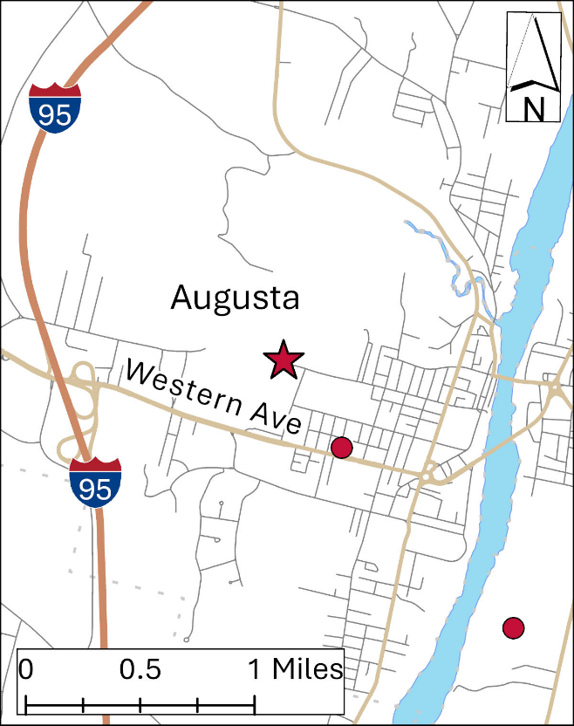
Site Description: A telescoping tower with wind speed and direction sensors situated on the roof of the Airport Terminal Building at the Augusta State Airport, 0.8 miles northwest of the state capitol building.

Parameters Monitored:
- Wind speed and direction
Monitoring Objectives:
- Modeling
Planned changes: None
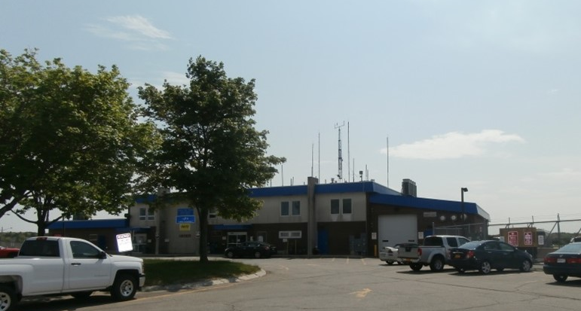

Town – Site: | Augusta - East Campus
County: | Kennebec
Address: | Arsenal St.
AQS Site ID: | 23-011-2501
Spatial Scale: | Regional
Statistical Area  (CBSA): | Augusta-Waterville, ME
Latitude: | 44.3009
Longitude: | -69.7713
Elevation: | 51 meters
Year Established: | 2026
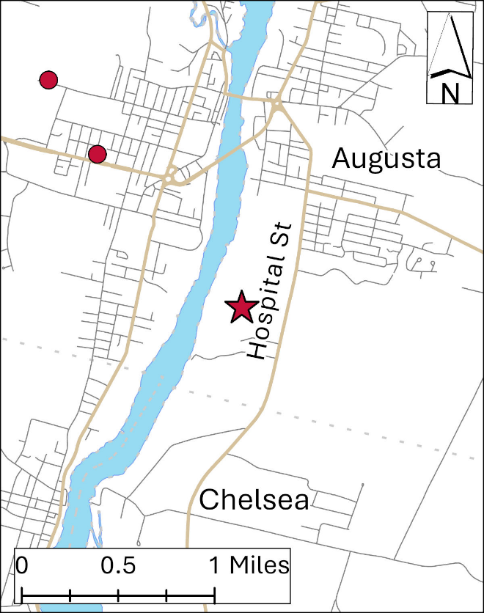
Site Description: The shelter is located on the southern edge of a parking lot with open exposure from the south and northwest.

Parameters Monitored:
- Ozone
Monitoring Objectives:
- SLAMS
- Monitoring long-range transport of pollutants on a regional scale
Planned Changes: None
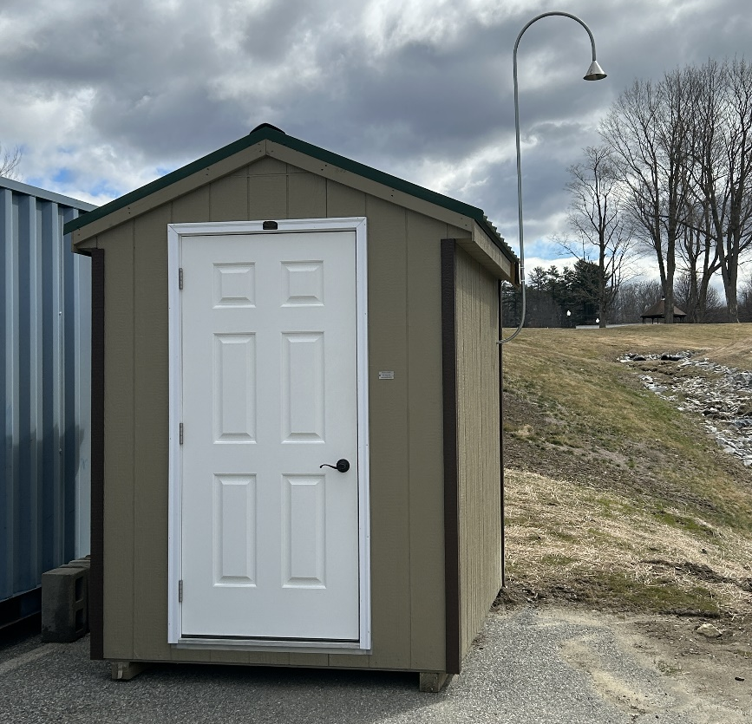

Town – Site: | Augusta – Lincoln St. School
County: | Kennebec
Address: | 30 Lincoln St.
AQS Site ID: | 23-011-0016
Spatial Scale: | Neighborhood
Statistical Area  (CBSA): | Augusta-Waterville, ME
Latitude: | 44.3123
Longitude: | -69.7867
Elevation: | 71 meters
Year Established: | 1999
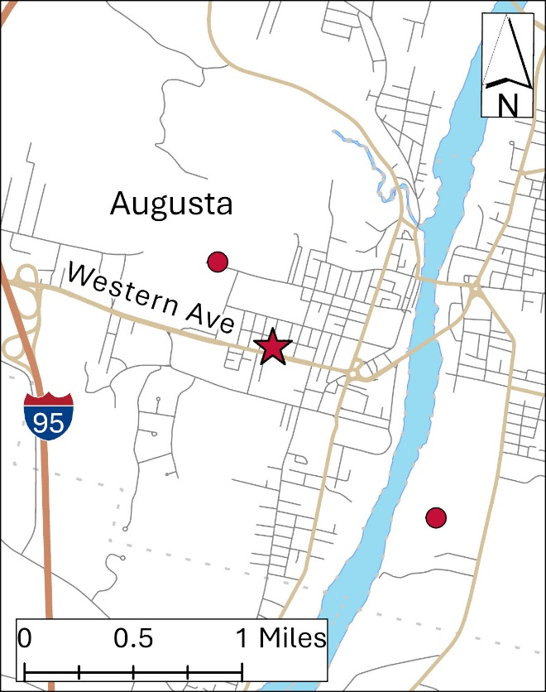
Site Description: Lincoln Street School is in Augusta just off Western Avenue, 0.4 miles northwest of the state capitol building. An aluminum platform is situated on the roof of the gymnasium where the monitoring equipment resides.

Parameters Monitored:

- Continuous PM_{2.5}
- Continuous PM₁₀
- Outdoor temperature
- Barometric pressure

Monitoring Objectives:

- SLAMS
- High population exposure

Planned Changes: None
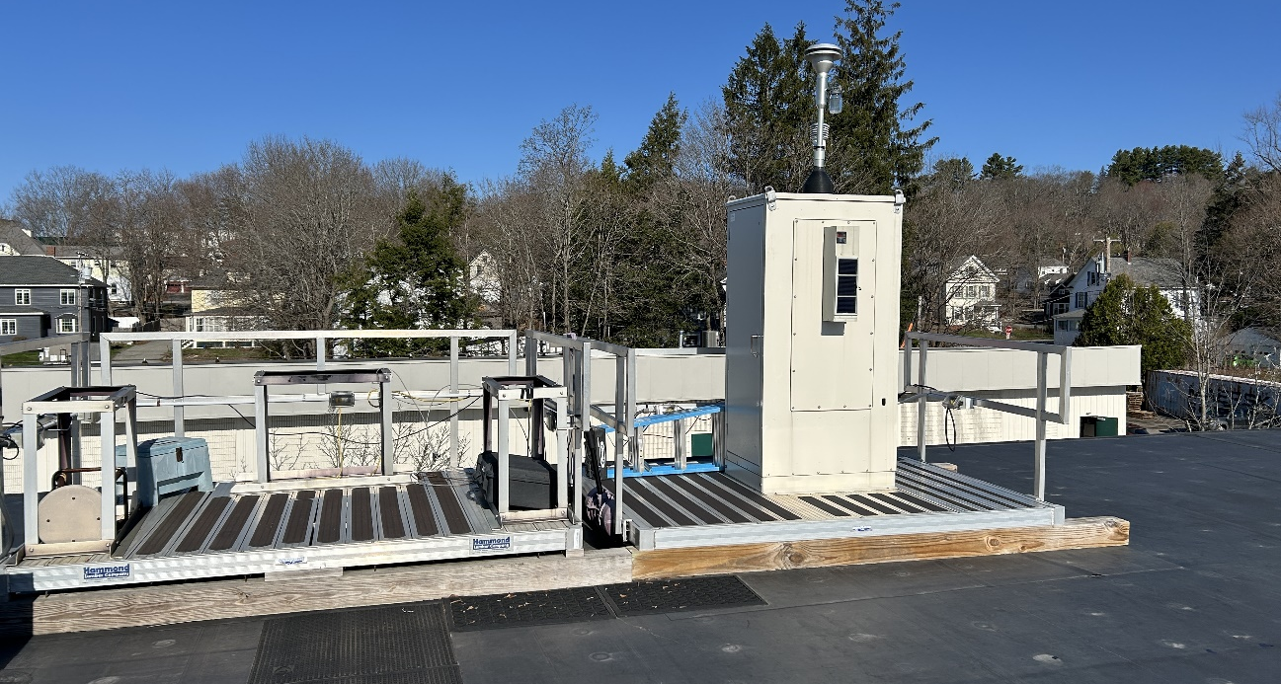
Town – Site: | Bangor - Mary Snow School
County: | Penobscot
Address: | 435 Broadway St.
AQS Site ID: | 23-019-0017
Spatial Scale: | Neighborhood
Statistical Area  (CBSA): | Bangor, ME
Latitude: | 44.8173
Longitude: | -68.7727
Elevation: | 54 meters
Year Established: | 2017
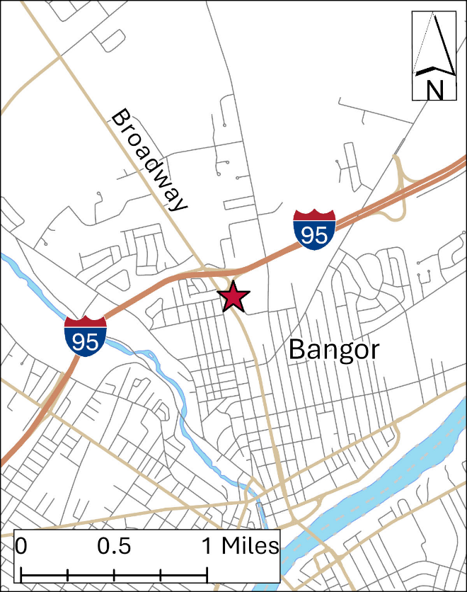
Site Description: Monitors are located on the roof of Mary Snow Elementary School, located on Broadway just south of the I 95 interchange in Bangor.

Parameters Monitored:

- Continuous PM_{2.5}
- PM_{2.5} (1 in 6)
- Continuous PM₁₀
- Hazardous air pollutants
- Outdoor temperature
- Barometric pressure
- Gamma radiation

Monitoring Objectives:

- SLAMS
- Forecasting and Mapping
- High population exposure

Planned Changes: None
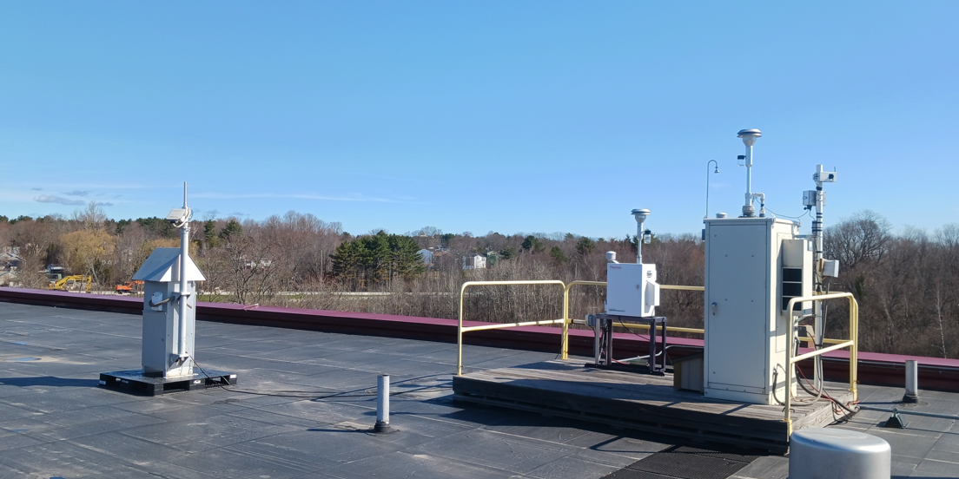
Town – Site: | Bar Harbor – Cadillac Mountain, Acadia National Park
County: | Hancock
Address: | Route 233
AQS Site ID: | 23-009-0102
Spatial Scale: | Regional
Statistical Area  (CBSA): | None
Latitude: | 44.3517
Longitude: | -68.2272
Elevation: | 463 meters
Year Established: | 1995
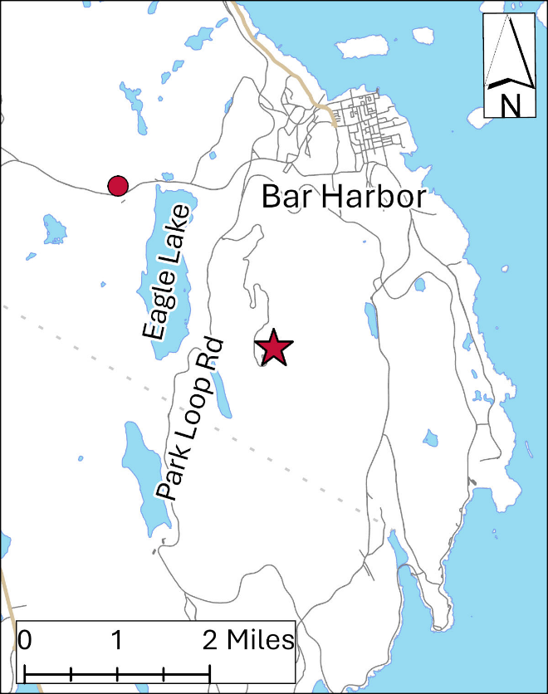
Site Description: Located on the top of Cadillac Mountain in Acadia National Park. It is a seasonal ozone site operating during the months of April to October. Meteorological parameters are also collected seasonally.

Parameters monitored:

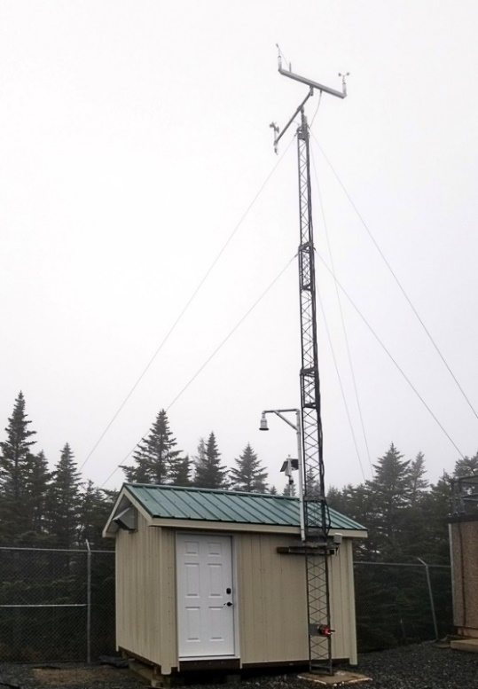
- Ozone
- Wind speed and direction
- Outdoor temperature
- Relative humidity

Monitoring Objectives:
- Monitoring long-range transport of pollutants on a regional scale
Planned Changes: None

Town – Site: | Bar Harbor – McFarland Hill, Acadia National Park
County: | Hancock
Address: | Route 233
AQS Site ID: | 23-009-0103
Spatial Scale: | Regional
Statistical Area  (CBSA): | None
Latitude: | 44.3771
Longitude: | -68.2609
Elevation: | 156 meters
Year Established: | 1998
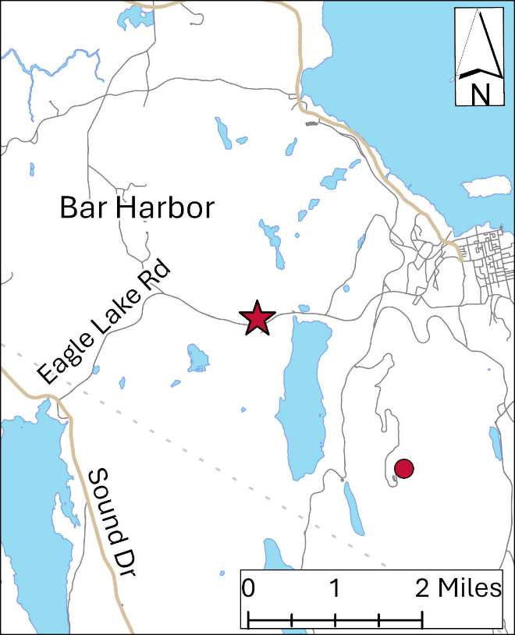
Site Description: This site is in a field on the side of McFarland Hill in Bar Harbor. Site slopes to the south/southeast with the hill rising to the north. The site was established by the NPS but has since grown to include a variety of monitors for EPA programs and networks.
ME DEP and NPS / ARD cooperate in the operation of this site, sharing resources and providing technical support to each other on a routine basis.
Parameters monitored (by type):
Particulate parameters:

- Continuous PM_{2.5}
- PM_{2.5} (1 in 3)
- Continuous PM₁₀
- Continuous PM_{C}
- Speciated PM_{2.5}
- OC / EC

Gaseous parameters:

- Ozone
- Carbon monoxide
- Sulfur dioxide
- Nitrogen oxide
- Reactive oxides of nitrogen (NO_{Y})

Meteorological parameters:

- Wind speed and direction
- Relative humidity
- Solar radiation
- Outdoor temperature
- Barometric pressure

Precipitation deposition:

- Precipitation accumulation
- Precipitation chemistry
- Mercury

Monitoring Objectives:

- Background
- NCORE
- IMPROVE
- CASTNET
- NADP (NTN and MDN)
- Long range transport of pollutants

Planned Changes: Currently there are no planned changes to this site; however, the OC/EC analyzer is starting to have performance issues and may get shut down. This analyzer is twice its expected lifespan and has far outlived the Rural Aerosol Intensive Network project it was purchased and operated for. The DEP will not expend additional funds to repair this instrument and will be shut down the next time it experiences operational failure. While there are no known changes planned for the CASTNET, NADP or IMPROVE networks at this site, the NPS is the primary operating agency for these networks, many minor or major changes to these networks and associated parameters are outside of the control of the ME DEP.
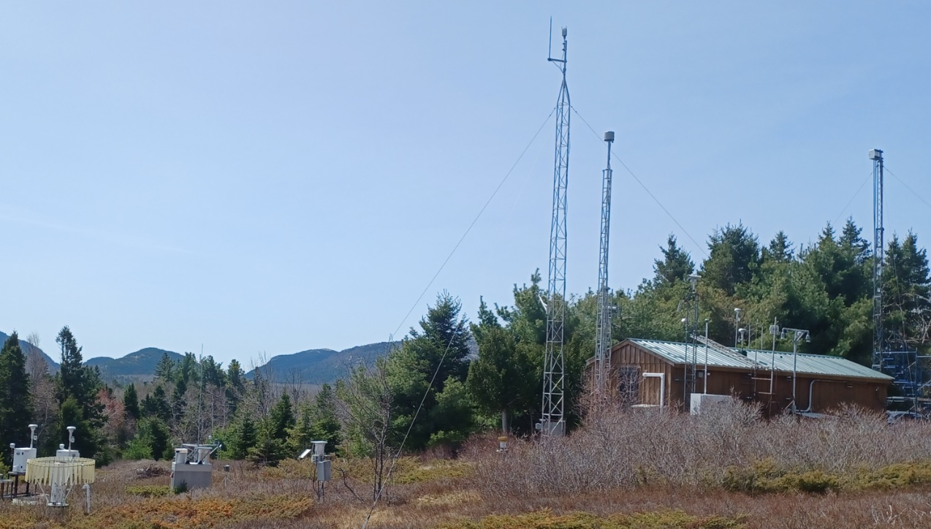
Town – Site: | Bethal – Smith Farm Rd.
County: | Oxford
Address: | Smith Farm Road
AQS Site ID: | 23-017-3002
Spatial Scale: | Regional
Statistical Area  (CBSA): | None
Latitude: | 44.377794
Longitude: | -70.854697
Elevation: | 203 Meters
Year Established: | 2016
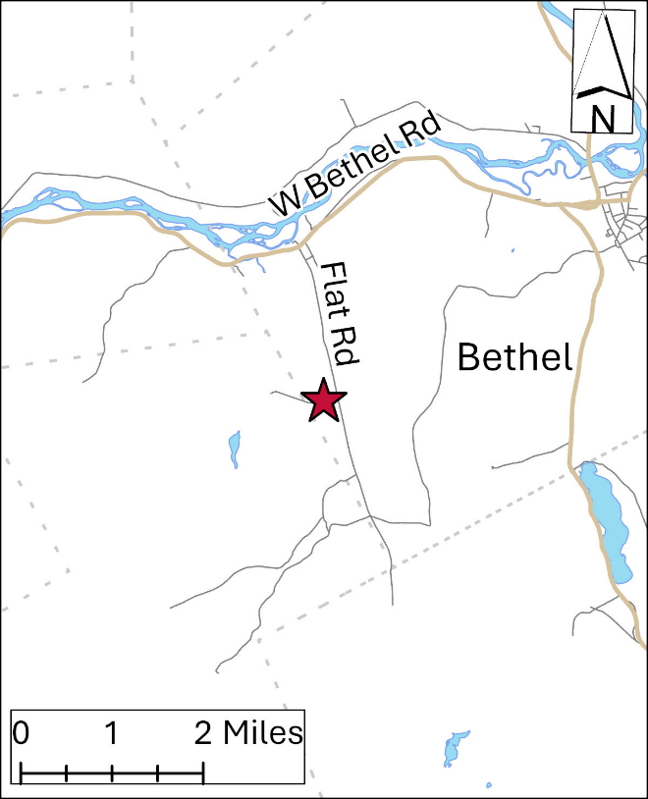
Site Description: The site is located approximately 3.5 miles southwest of Bethel, Maine on Smith Farm Road. The shelter is situated in a field along the power line right-of-way.
Parameters Monitored:

- Ozone

Monitoring Objectives:

- SLAMS
- Forecasting and Mapping

Planned Changes: The shelter may be replaced as the current shelter is underutilized in the current location, and the Maine DEP would benefit from having this shelter available for another use. This will not occur before the next Annual Monitoring Plan.
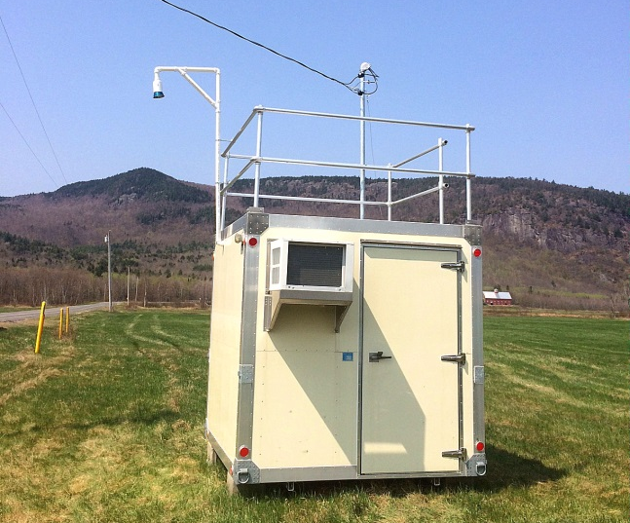
Town – Site: | Bridgton
County: | Cumberland
Address: | Upper Ridge Road
AQS Site ID: | 23-005-0002
Spatial Scale: | Regional
Statistical Area  (CBSA): | Portland-South Portland-Biddeford, ME
Latitude: | 44.1074
Longitude: | -70.7290
Elevation: | 223 meters
Year Established: | 1980
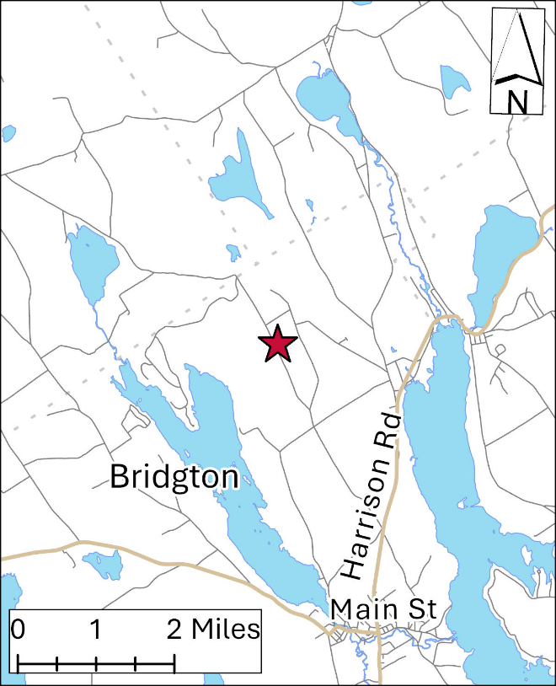
Site Description: Site is located on a ridge in an open field area just off the Upper Ridge Road. While this site is a Maine DEP location, the weekly workload is contracted out to the Maine Lakes Environmental Association (LEA).
Parameters Monitored:

- Precipitation accumulation
- Precipitation chemistry
- Mercury

Monitoring Objectives:

- Long term trends of deposition

Planned Changes: None
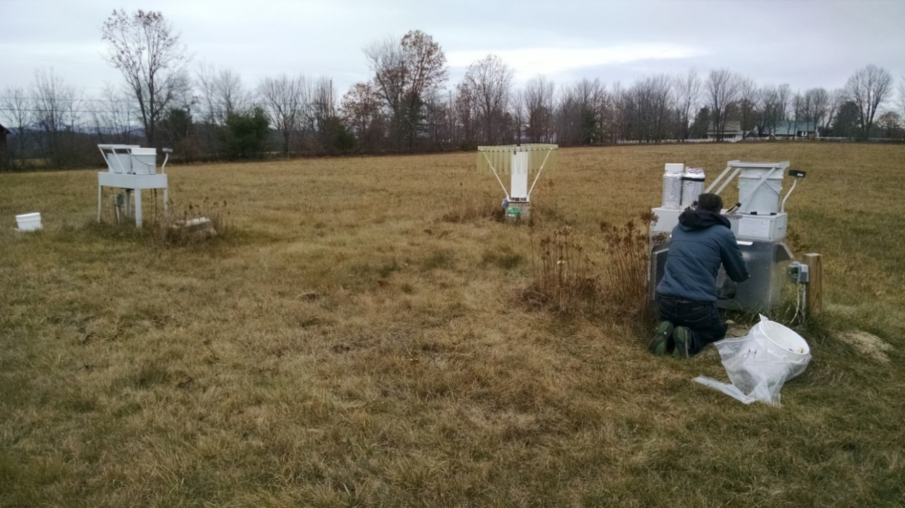
Town – Site: | Cape Elizabeth, Two Lights State Park
County: | Cumberland
Address: | Two Lights State Park
AQS Site ID: | 23-005-2003
Spatial Scale: | Regional
Statistical Area  (CBSA): | Portland-South Portland-Biddeford, ME
Latitude: | 43.5610
Longitude: | -70.2073
Elevation: | 24 meters
Year Established: | 1981
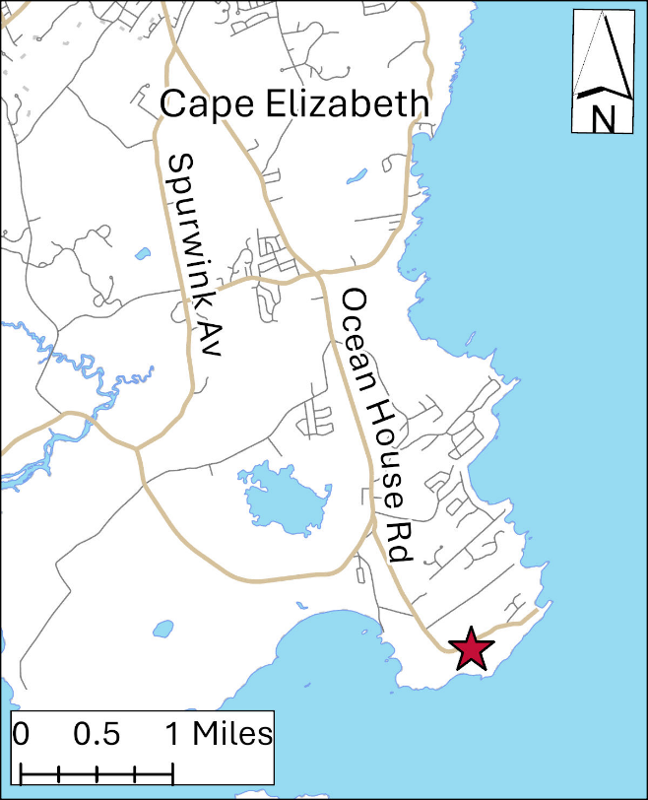
Site Description: The Cape Elizabeth site is in an open elevated area in the Two Lights State Park in Cape Elizabeth. Ozone is monitored year around, and meteorological parameters are monitored seasonally from April to September. Maine DEP also provides in-person support for the EPA operated PANDORA instrument hosted at this monitoring location.

Parameters Monitored:

- Ozone
- Wind speed and direction
- Relative humidity
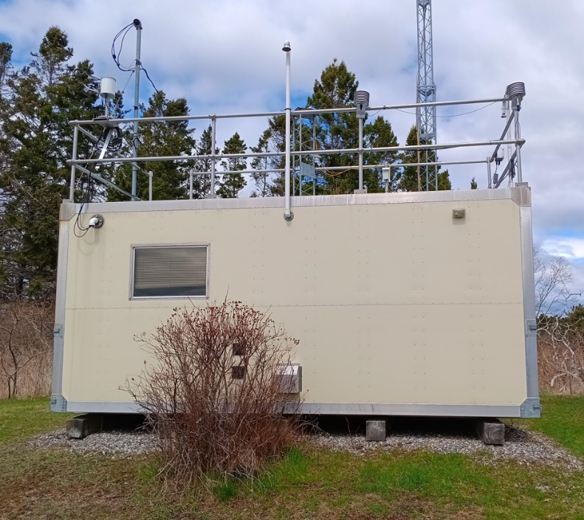
- Solar radiation
- UV-b radiation
- Outdoor temperature
- Barometric pressure
- Pandora

Monitoring Objectives:

- SLAMS
- Long-range transport of pollutants

Planned Changes: This shelter is currently under-utilized. The Maine DEP would benefit from replacing this shelter will a smaller shelter, allowing this shelter to be available for other uses. This will not occur before the next Annual Monitoring Plan.
Town – Site: | Caribou – Caribou Airport
County: | Aroostook
Address: | Caribou Airport
AQS Site ID: | 23-003-1002
Spatial Scale: | Regional
Statistical Area  (CBSA): | None
Latitude: | 46.8683
Longitude: | -67.9931
Elevation: | 191 meters
Year Established: | 1982
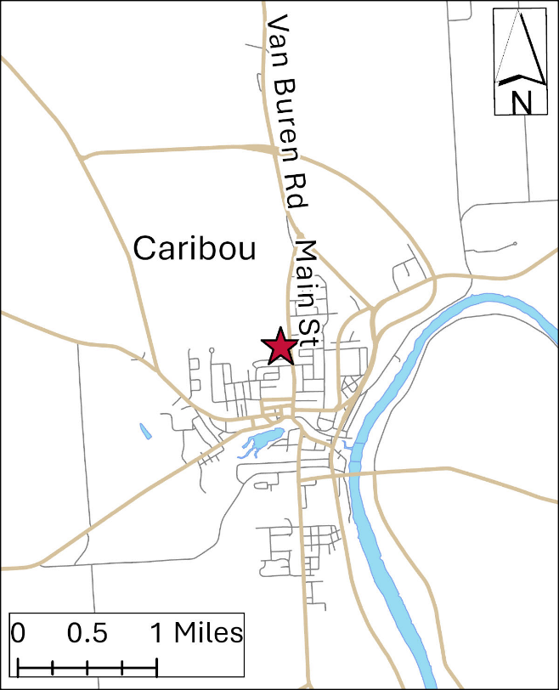
Site Description: The site is in a grassy area inside the fence and off the south end of the runway at Caribou Airport.

Parameters Monitored:

- Precipitation accumulation
- Precipitation chemistry
- Mercury

Monitoring Objectives:

- Long term trends of deposition

Planned Changes: None
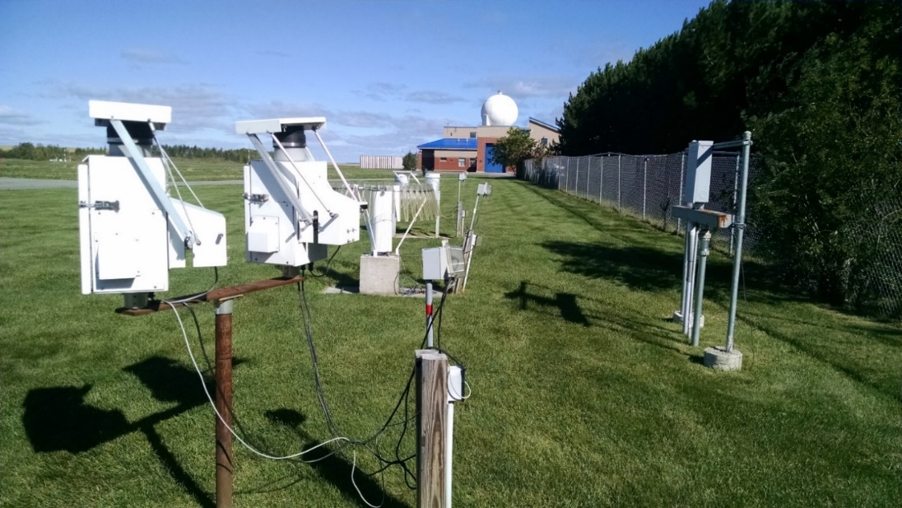
Town – Site: | Durham – Fire Station
County: | Androscoggin
Address: | Route 9
AQS Site ID: | 23-001-0014
Spatial Scale: | Regional
Statistical Area  (CBSA): | Lewiston-Auburn, ME
Latitude: | 43.9745
Longitude: | -70.1249
Elevation: | 50 meters
Year Established: | 2004
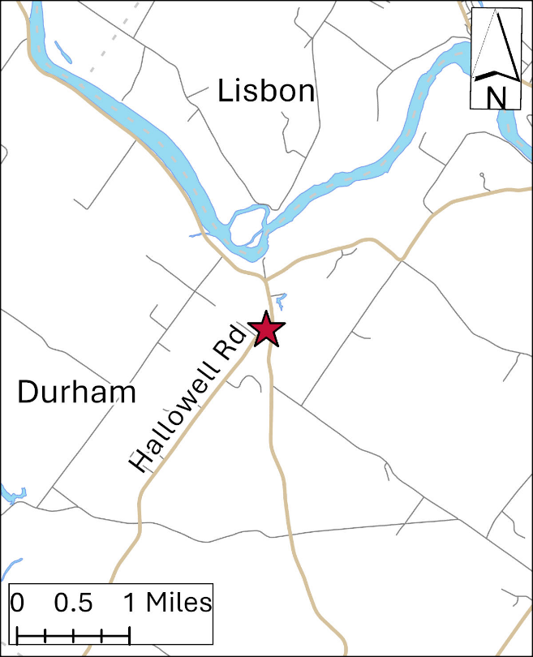
Site Description: The site is located on the grounds of the Durham Fire Station, 9 ½ miles southeast of Lewiston. An ozone monitor is located within an environmentally controlled shelter that was installed in 2006. In the summer of 2022, a new sloped roof was installed onto the shelter.

Parameters Monitored:

- Ozone

Monitoring Objectives:

- SLAMS

Planned Changes: None
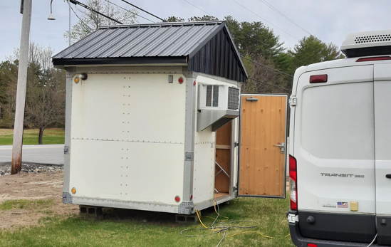
Town – Site: | Freeport – Wolfes Neck Farm
County: | Cumberland
Address: | Wolfe’s Neck Road
AQS Site ID: | 23-005-9002
Spatial Scale: | Regional/Neighborhood
Statistical Area  (CBSA): | Portland-South Portland-Biddeford, ME
Latitude: | 43.8325
Longitude: | -70.0644
Elevation: | 27 meters
Year Established: | 1998
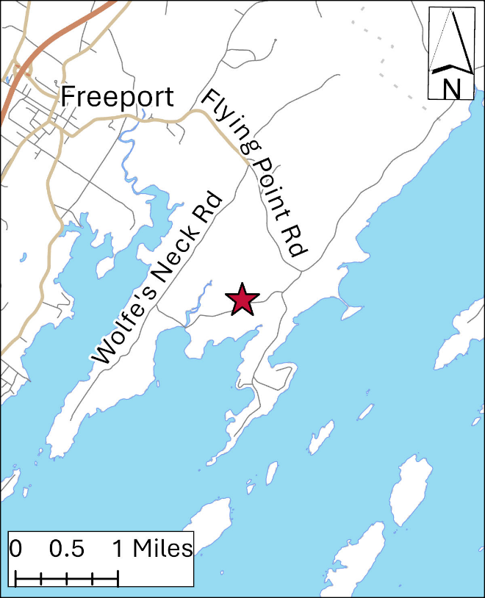
Site Description: Site is located within a fenced-in area in the middle of a large open field used as a pasture by the Wolfe’s Neck farm. This is the only site in Maine that is part of the NADP PFN subnetwork, measuring PFAS levels collected in precipitation samples. The new Portland Ocean Gateway monitoring location could not fit the RADNET monitor that was previously located at the old Dearing Oakes Park monitoring location. DEP coordinated with the US EPA RADNAT program operators to relocate the RADNET to this monitoring location.

Parameters Monitored:

- Precipitation accumulation
- Precipitation chemistry
- PFAS precipitation deposition
- Gamma radiation

Monitoring Objectives:

- Long term trends of deposition
- IMPROVE

Planned Changes: None

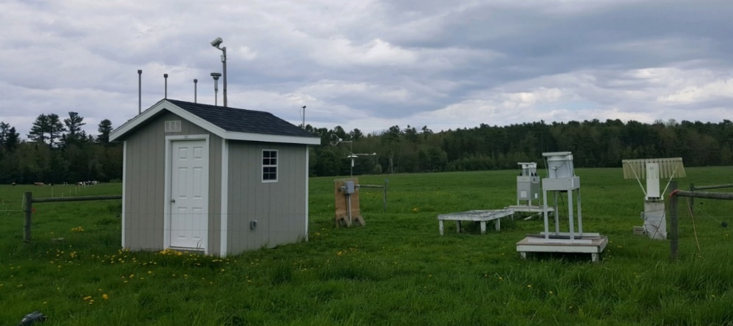
Town – Site: | Greenville
County: | Piscataquis
Address: | Greenville Municipal Airport
AQS Site ID: | 23-021-0001
Spatial Scale: | Regional
Statistical Area  (CBSA): | None
Latitude: | 45.463
Longitude: | -69.55579
Elevation: | 424 meters
Year Established: | 2021
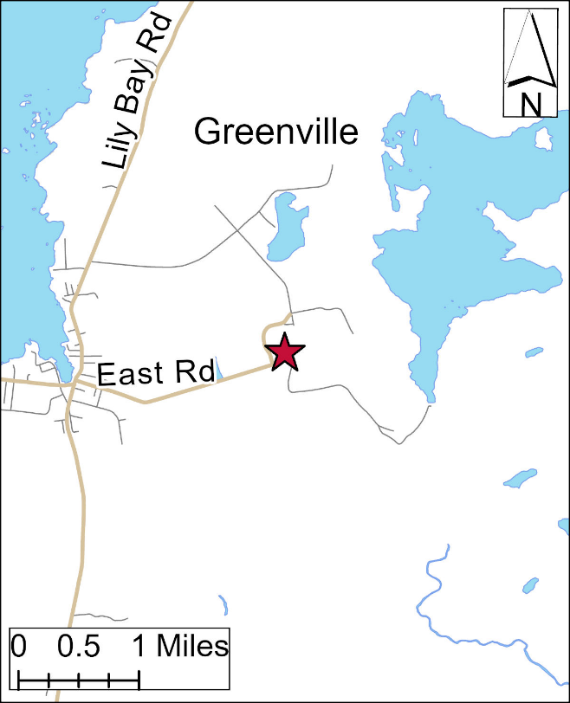
Site Description: The samplers are in a field on the western edge of the Greenville Municipal Airport. The samplers were previously located in Greenville Junction but were moved as the previous site was experiencing deterioration in siting quality due to vegetation growth and land use changes. Because of the proximity of the two locations, the locations are treated as the same for long-term trends.

Parameters Monitored:

- Precipitation accumulation
- Precipitation chemistry
- Mercury

Monitoring Objectives:

- Long term trends of deposition

Planned Changes: None
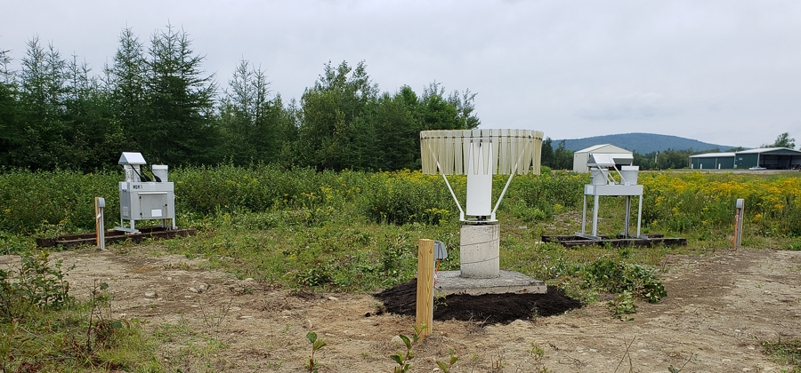
Town – Site: | Holden – Riders Bluff
County: | Penobscot
Address: | Summit of Rider’s Bluff
AQS Site ID: | 23-019-4008
Spatial Scale: | Regional
Statistical Area  (CBSA): | Bangor, ME
Latitude: | 44.7365
Longitude: | -68.6711
Elevation: | 250 meters
Year Established: | 1993
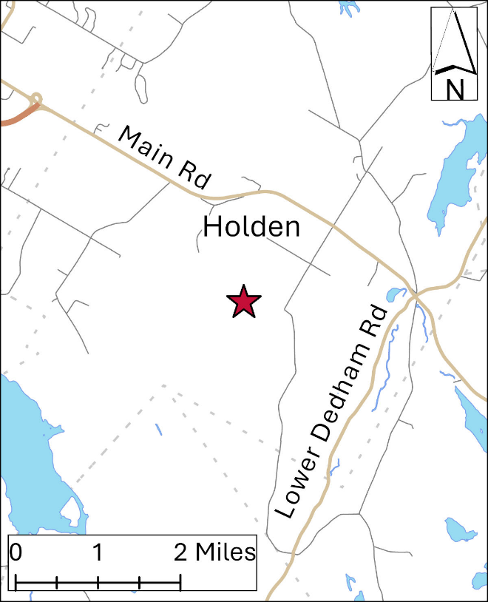
Site Description: Site is a transmission tower location for a local TV station at the top of a hill in Holden with good exposure in all directions.

Parameters Monitored:

- Ozone

Monitoring Objectives:

- SLAMS
- Long range transport of pollutants

Planned Changes: None
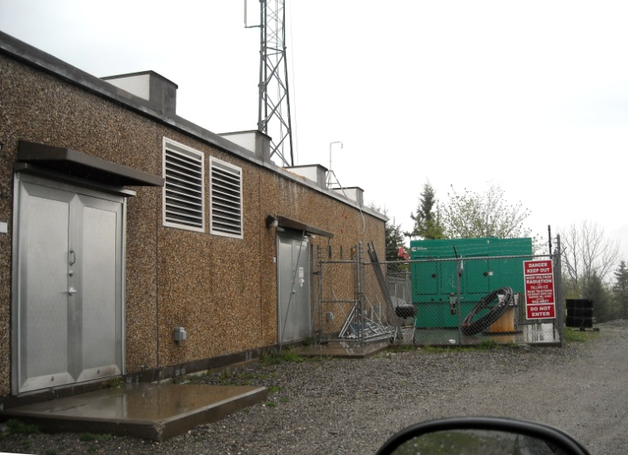
Town – Site: | Jonesport – Coast Guard Station
County: | Washington
Address: | 9 Bridge St.
AQS Site ID: | 23-029-0021
Spatial Scale: | Regional
Statistical Area  (CBSA): | None
Latitude: | 44.5276
Longitude: | -67.6154
Elevation: | 2 meters
Year Established: | 2022
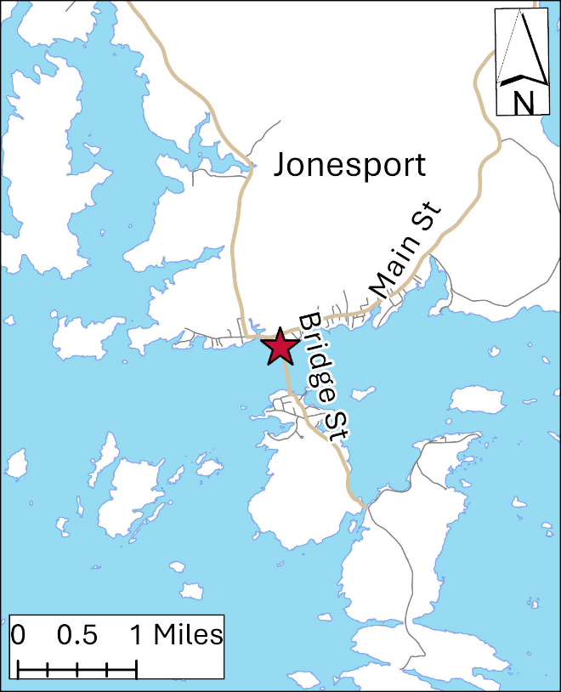
Site Description: Monitor located in a shelter at the US Coast Guard Station parking lot. This site replaces the Jonesport Public Landing site which was discontinued due to the planned demolition of the public landing structure that housed the monitoring equipment.

Parameters Monitored:

- Ozone

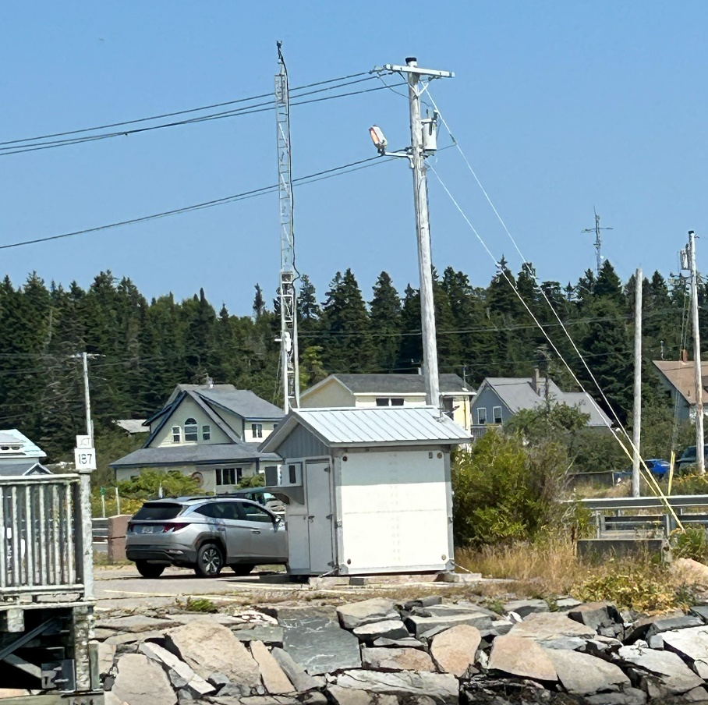
Monitoring Objectives:

- SLAMS
- EMP

Planned Changes: None

Town – Site: | Lewiston – Country Kitchen Parking Lot
County: | Androscoggin
Address: | Canal Street
AQS Site ID: | 23-001-0011
Spatial Scale: | Neighborhood
Statistical Area  (CBSA): | Lewiston-Auburn ME
Latitude: | 44.0894
Longitude: | -70.2141
Elevation: | 50 meters
Year Established: | 1981
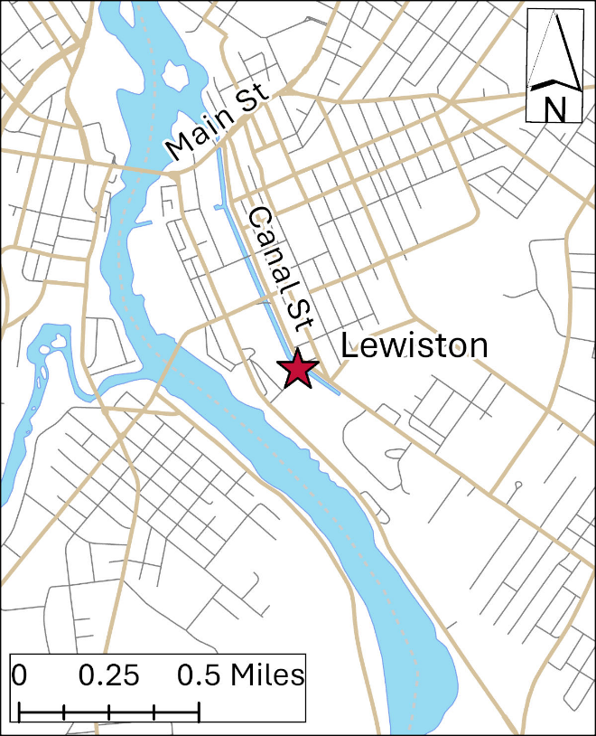
Site Description: The site is in downtown Lewiston in the parking lot of the Country Kitchen Bakery. An environmentally controlled shelter houses the continuous instruments and HAPs, with a filter-based PM sampler situated on the roof.

Parameters Monitored:

- Continuous PM_{2.5}
- PM_{2.5} (1 in 6)
- Continuous PM₁₀
- Hazardous air pollutants
- Outdoor temperature
- Barometric pressure

Monitoring Objectives:

- SLAMS
- High population exposure

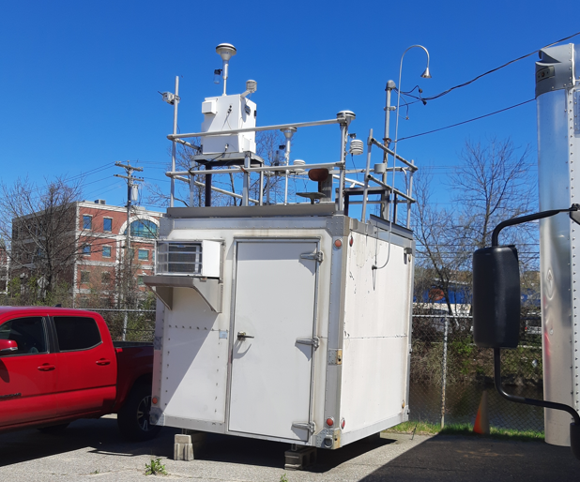
Planned Changes: The shelter is to be replaced with a new shelter in an adjacent parking spot in the summer of 2026.

Town – Site: | Madawaska -Public Safety Building
County: | Aroostook
Address: | East Maine St.
AQS Site ID: | 23-003-0014
Spatial Scale: | Neighborhood
Statistical Area  (CBSA): | None
Latitude: | 47.3553
Longitude: | -68.3211
Elevation: | 177 meters
Year Established: | 2009
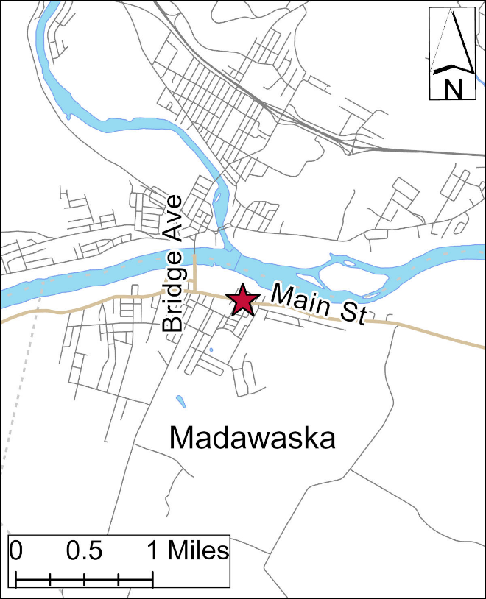
Site Description: Equipment is located on a monitoring platform on the roof of the Madawaska Public Safety Building.

Parameters Monitored:

- Continuous PM_{2.5}
- Continuous PM₁₀
- Outdoor temperature
- Barometric pressure

Monitoring Objectives:

- SLAMS

Planned Changes: None
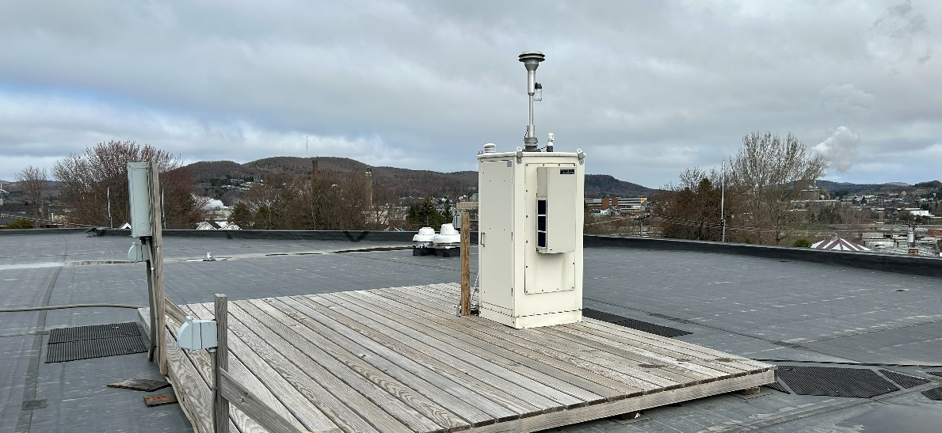

Town – Site: | Phippsburg - Popham Beach State Park
County: | Sagadahoc
Address: | 711 Popham Road.
AQS Site ID: | 23-023-0007
Spatial Scale: | Regional
Statistical Area  (CBSA): | None
Latitude: | 43.7362
Longitude: | -69.7976
Elevation: | 5 meters
Year Established: | 2022
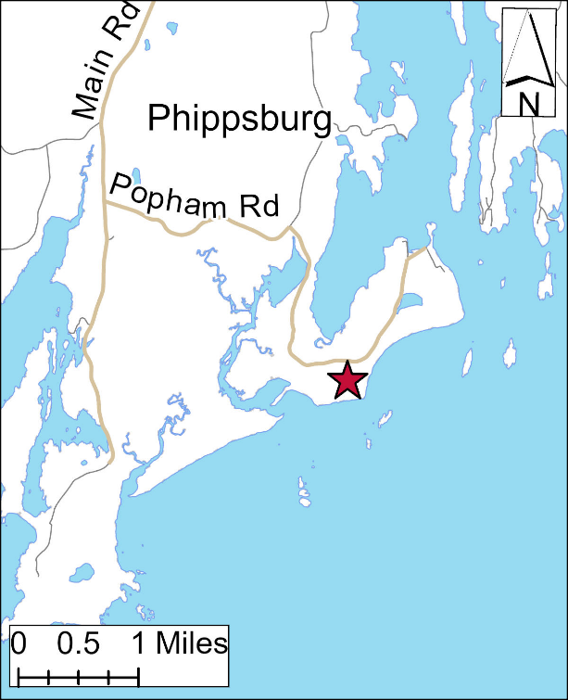
Site Description: Environmentally controlled cabinet installed in a utility room of the “Bath House” at the State Park.

Parameters Monitored:

- Ozone

Monitoring Objectives:

- SLAMS
- Long-range transport of pollutants

Planned Changes: The building that our equipment resides in is under threat from costal erosion caused by the Morse stream meandering along the coastline and two back-to-back winter storms in December 2023 and January 2024 that caused significant loss of sand. The Bureau of Park and Lands is investigating options for the future, which may include relocating or removing the building.
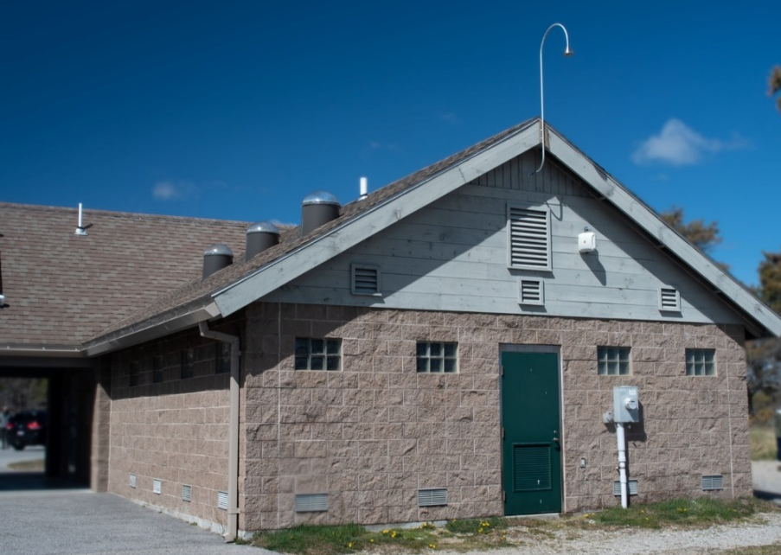
Town – Site: | Port Clyde – Marshall Point Lighthouse
County: | Knox
Address: | Marshall Point Road
AQS Site ID: | 23-013-0004
Spatial Scale: | Regional
Statistical Area  (CBSA): | Rockland, ME
Latitude: | 43.9180
Longitude: | -69.2608
Elevation: | 9 Meters
Year Established: | 1987
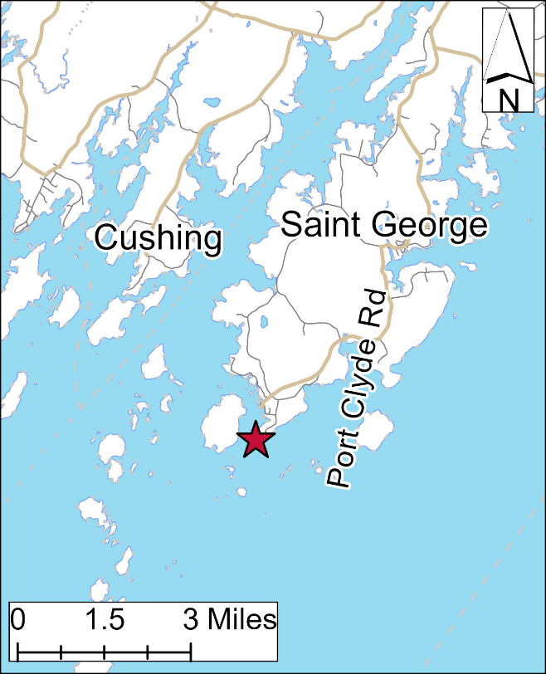
Site Description: A small temperature controlled wooden shelter behind the Marshall Point Lighthouse Museum.

Parameters Monitored:

- Ozone

Monitoring Objectives:

- SLAMS
- Long-range transport of pollutants

Planned Changes: None.
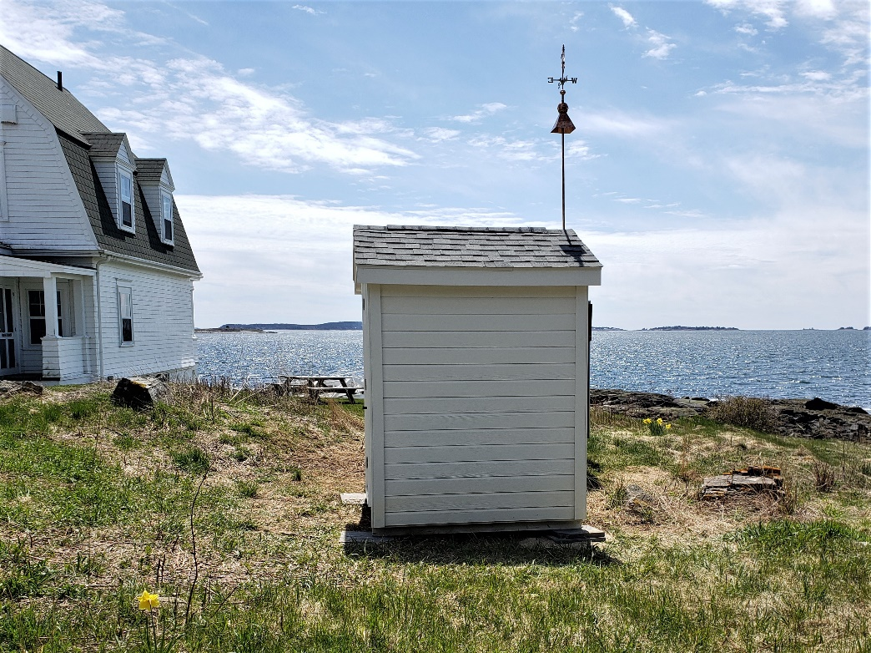
Town – Site: | Portland – Ocean Gateway
County: | Cumberland
Address: | 65 Thames Street
AQS Site ID: | 23-005-6606
Spatial Scale: | Middle / Neighborhood
Statistical Area  (CBSA): | Portland-South Portland-Biddeford, ME
Latitude: | 43.6606
Longitude: | -70.2455
Elevation: | 4 meters
Year Established: | 2019
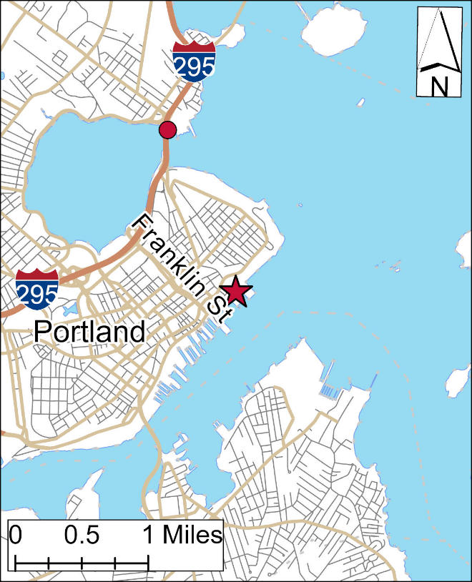
Site Description: The monitoring shelter is located behind the Narrow Guage Railroad building on Thames Street near the cruise ship terminal building. This location has been a special project location for HAPs since 2019, expanding into a replacement site for the Portland Dearing Oak Park monitoring location that was forced to be moved as it reside in the planned expansion of the Portland greenbelt bike path.
Parameters Monitored:

- Continuous PM_{2.5}
- PM_{2.5} (1 in 6)
- Continuous PM₁₀
- Outdoor temperature
- Barometric pressure
- Ozone
- Nitrogen oxide
- Nitrogen dioxide
- Nitrogen oxides
- HAPS
- Sulfur dioxide
- Carbon monoxide

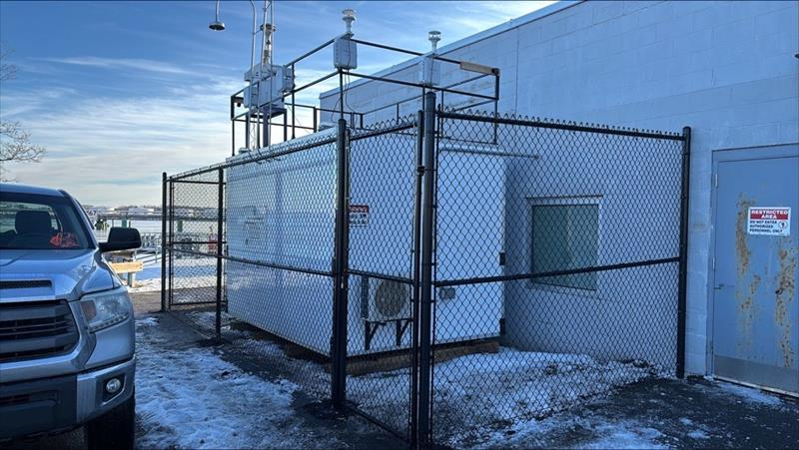
Monitoring Objectives:

- SLAMS
- High population exposure

Planned Changes: SO₂ and CO may be shut down after one year of valid sample collection. The initial inclusion of these parameters is to assess the need to monitor these parameters at this new location. Once the first year of collection has finished, ME DEP will review the data to determine whether to maintain either monitor permanently or to establish a design value (3 years), or to shut down.
Town – Site: | Portland – Tukey’s Bridge
County: | Cumberland
Address: | Tukey’s Bridge (Route 295)
AQS Site ID: | 23-005-0015
Spatial Scale: | Micro
Statistical Area  (CBSA): | Portland-South Portland-Biddeford, ME
Latitude: | 43.6780
Longitude: | -70.2562
Elevation: | 6 meters
Year Established: | 1981
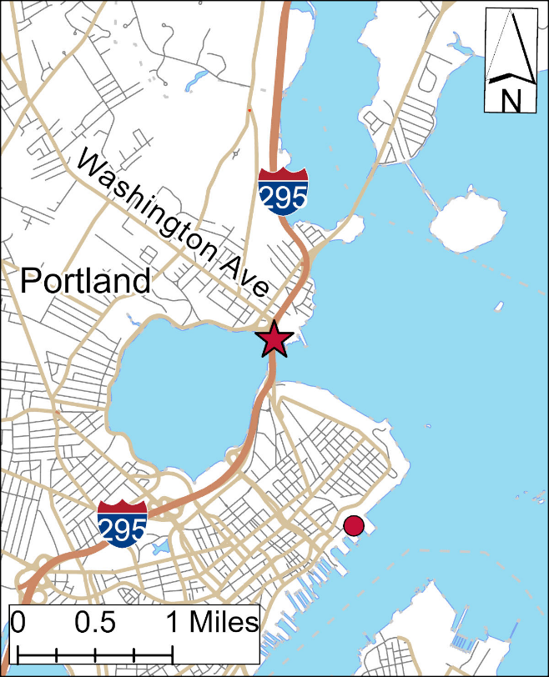
Site Description: The monitoring platform is located beside the I-295 Washington exit on the north side of Tukey’s Bridge. This section of road has the highest annual average daily traffic volume in the state.

Parameters Monitored:

- Continuous PM_{2.5}
- Continuous PM₁₀
- Outdoor temperature
- Barometric pressure

Monitoring Objectives:

- SLAMS
- High traffic volume

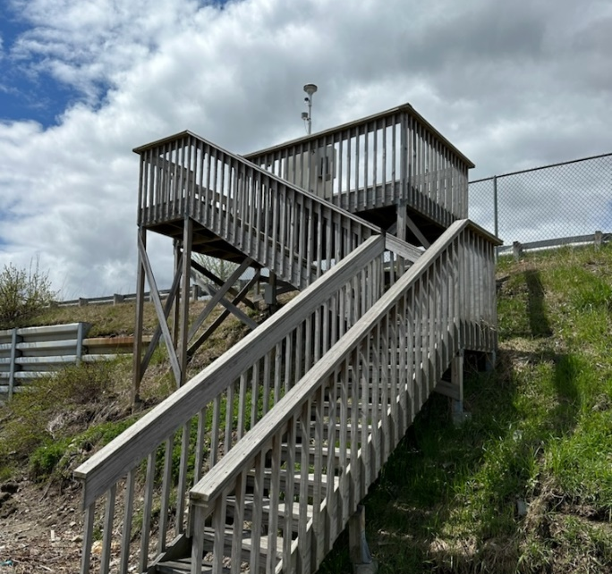
Planned Changes: Security has been an on-going issue at this site. ME DEP has been unable to find a contractor willing to install a security fence at this location that would not extend outside of our existing footprint. Additionally, Maine DOT is planning to widen the exit to provide an additional exit lane directly to the new Roux Institute campus. Dependent on where the new exit lane begins, this station may be forced to shut down.

Town – Site: | Presque Isle – DEP Regional Office
County: | Aroostook
Address: | 528 Central Drive
AQS Site ID: | 23-003-1008
Spatial Scale: | Neighborhood
Statistical Area  (CBSA): | None
Latitude: | 46.6984
Longitude: | -68.0389
Elevation: | 158 meters
Year Established: | 1983
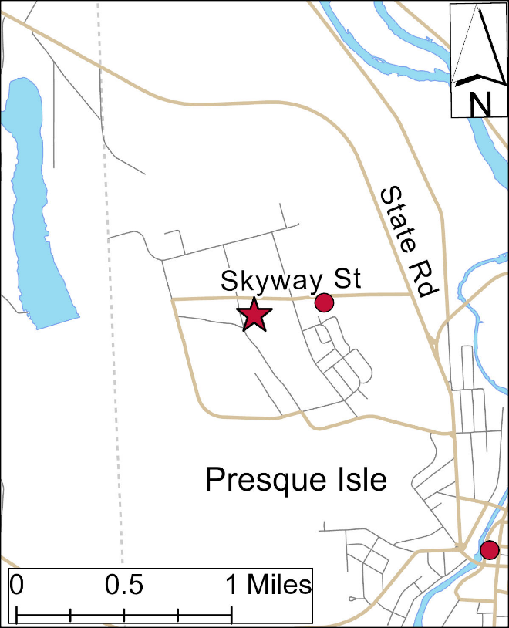
Site Description: Suburban and rural background monitoring site for PM_{2.5} in Northern Maine located in a field next to the regional office in Presque Isle. The Department also provides in-person support for the Colorado State University UV-b monitoring network at this location.

Parameters Monitored:

- Continuous PM_{2.5}
- Continuous PM₁₀
- Outdoor temperature
- Barometric pressure
- UV-b radiation

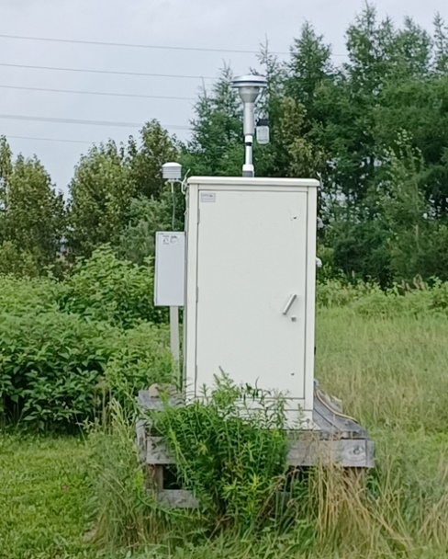
Monitoring Objectives:

- SLAMS
- Background/Mapping

Planned Changes: A new structure is expected to be constructed in the field near the monitoring station. This new structure may impact the siting quality of this monitoring station. Additionally, the new Mi’kmaq monitoring station may cause this station to become redundant. The DEP is considering shutting down the PM monitoring equipment.

Town – Site: | Presque Isle - Riverside
County: | Aroostook
Address: | Riverside Street
AQS Site ID: | 23-003-1011
Spatial Scale: | Neighborhood
Statistical Area  (CBSA): | None
Latitude: | 46.6823
Longitude: | -68.0156
Elevation: | 131 meters
Year Established: | 1993
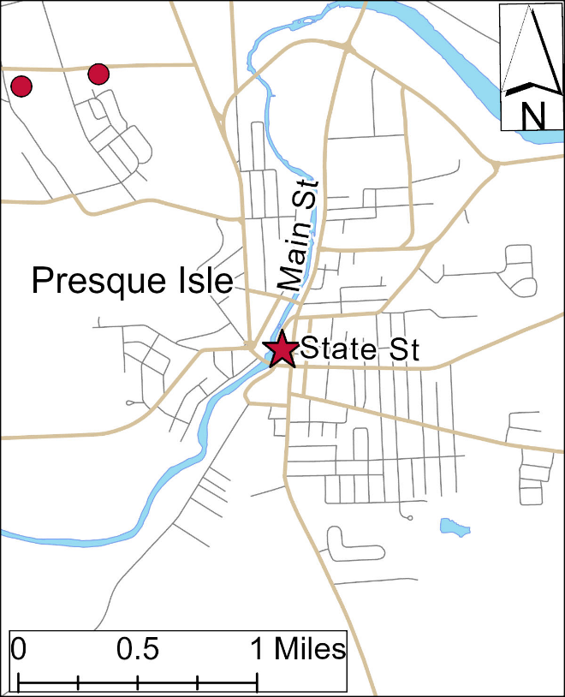
Site Description: The monitoring shelter is located beside a parking lot off Main St. The site has some air flow restrictions with nearby downtown buildings and trees. In the spring, when reduced air flow restricts mixing, road dust will build up at the ground level causing short-duration (1-4 hours) localized concentration spikes of ground-level PM.

Parameters Monitored:

- Continuous PM_{2.5}
- PM_{2.5} (1 in 3)
- Continuous PM₁₀
- Hazardous air pollutants
- Outdoor temperature
- Barometric pressure

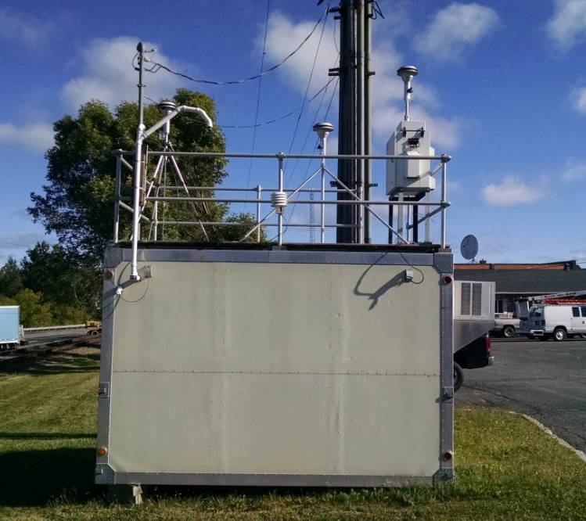
Monitoring Objectives:

- SLAMS

Planned Changes: The current shelter will be replaced this summer (2026) with a new 8’x8’ shelter. The collocated BAM will not be installed in the new shelter. A ceilometer will be added to the site.

Town – Site: | Rumford – Rumford Avenue Parking Lot
County: | Oxford
Address: | Rumford Ave. Parking Lot
AQS Site ID: | 23-017-2011
Spatial Scale: | Neighborhood
Statistical Area  (CBSA): | None
Latitude: | 44.5514
Longitude: | -70.5463
Elevation: | 135 Meters
Year Established: | 1998
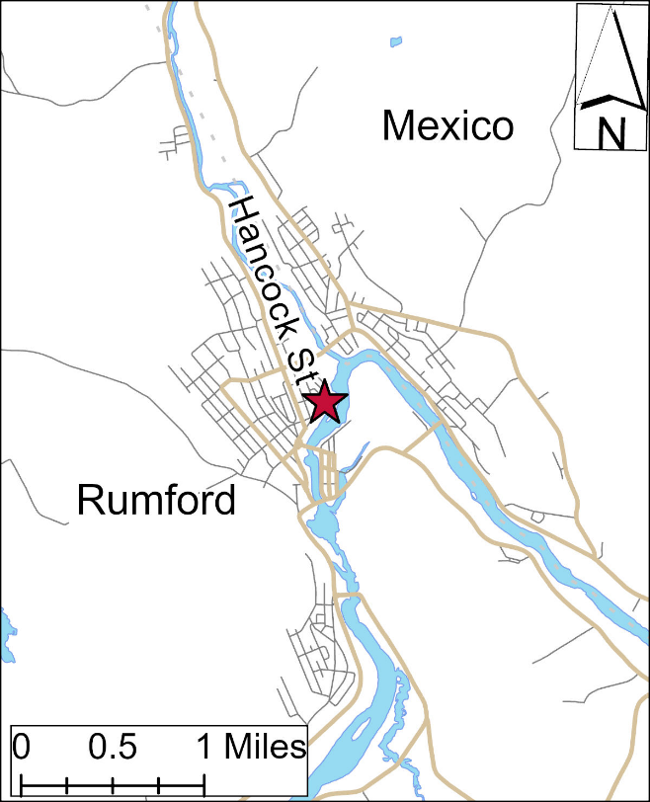
Site Description: The site is located just off the parking lot used by employees and contractors for, but across the river from, the Nine Dragons – Rumford paper mill. This site is in a complex river valley and routinely impacted by inversions. A wind speed and direction sensor is installed to assist in the assessment of inversion impacts but cannot be sited for regional use.

Parameters Monitored:

- Continuous PM_{2.5}
- Continuous PM₁₀
- Hazardous air pollutants
- Outdoor temperature
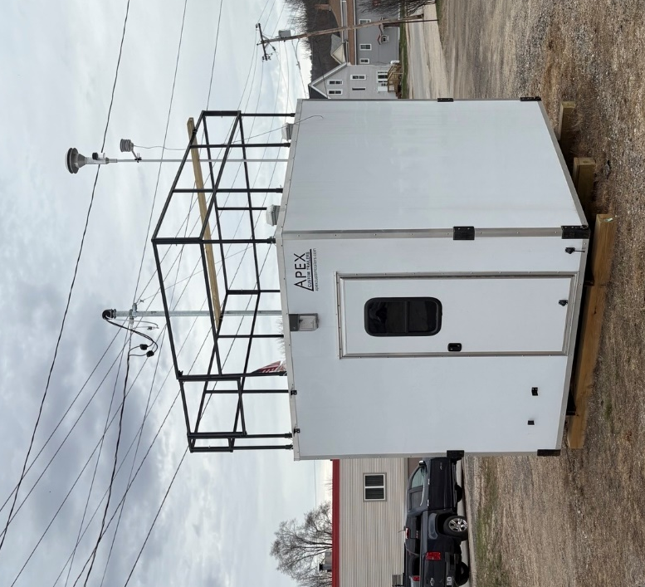
- Barometric pressure
- Wind speed and direction (local)

Monitoring Objectives:

- SLAMS
- Population exposure
- Forecasting/mapping for the Western Mountains region

Planned Changes: None

Town – Site: | Shapleigh – Shapleigh Ball Park
County: | York
Address: | Route 11
AQS Site ID: | 23-031-0040
Spatial Scale: | Regional
Statistical Area  (CBSA): | Portland-South Portland-Biddeford, ME
Latitude: | 43.5889
Longitude: | -70.8773
Elevation: | 171 Meters
Year Established: | 2008
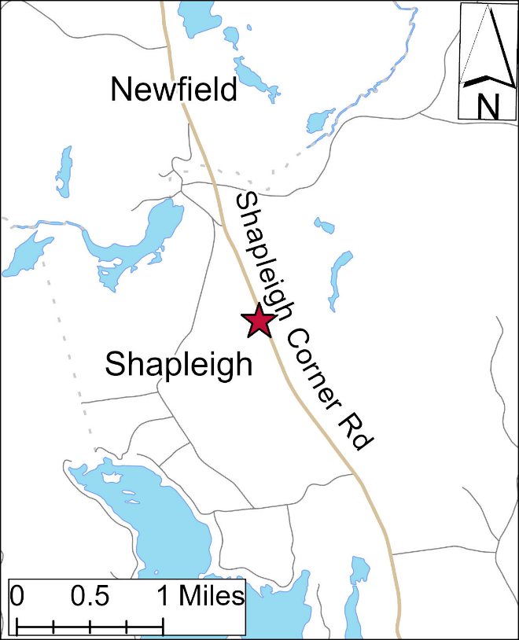
Site Description: The site is in a baseball outfield off route 11 with open fetch from the south to west.

Parameters Monitored:

- Ozone

Monitoring Objectives:

- SLAMS
- EMP
- Monitoring long range transport of pollutants on a regional scale.

Planned Changes: None
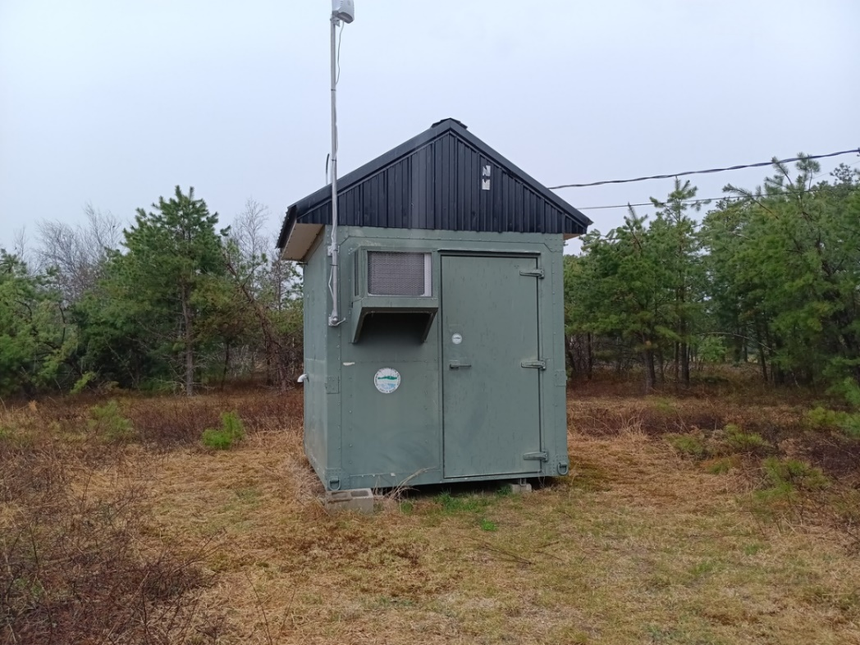
Town – Site: | Wells – Wells Harbour  Community Park
County: | York
Address: | 345 Harbour Rd.
AQS Site ID: | 23-031-2502
Spatial Scale: | Regional
Statistical Area  (CBSA): | Portland-South Portland-Biddeford, ME
Latitude: | 43.3206
Longitude: | -70.5654
Elevation: | 4 meters
Year Established: | 2026
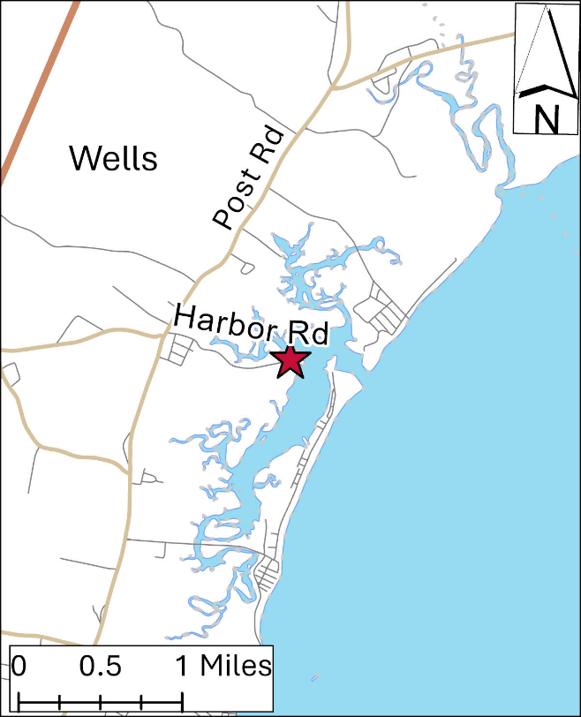
Site Description: This is a new site that replaced the long-running Kennebunkport site that was threatened during coastal storms. The shelter is located off the parking lot used by trucks with boat trailers. The site has open fetch from the northeast to the southwest.

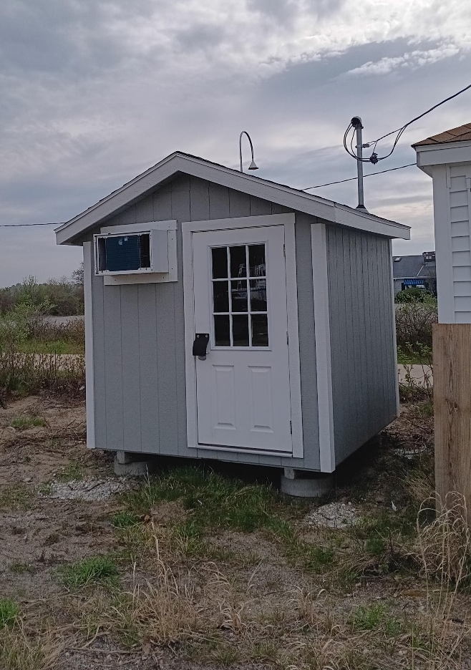
Parameters Monitored:

- Ozone

Monitoring Objectives:

- SLAMS
- Monitoring long-range transport of pollutants on a regional scale
Planned Changes: None

Tribal Monitoring Stations

Town – Site: | Presque Isle – Mi’kmaq
County: | Aroostook
Address: | 1 Skypot Lane
AQS Site ID: | 23-003-1102
Spatial Scale: | Neighborhood
Statistical Area  (CBSA): | None
Latitude: | 46.6991
Longitude: | -68.0321
Elevation: | 163 meters
Year Established: | 2026
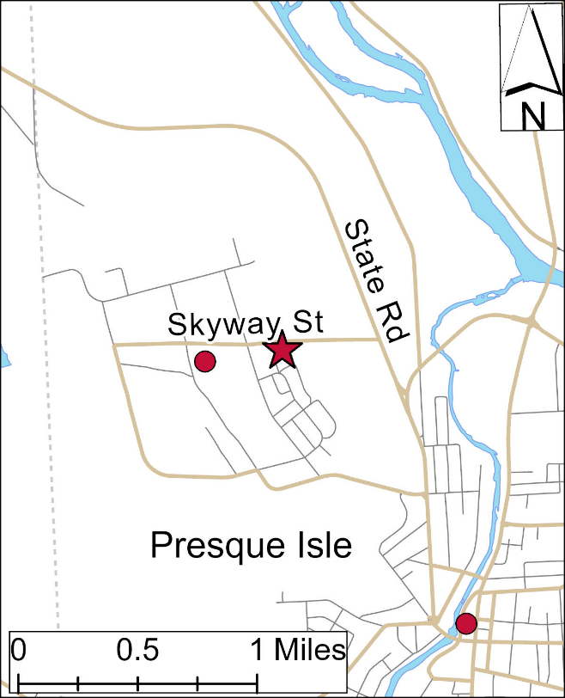
Site Description: This site replaced the previous Mi’kmaq monitoring located that was being crowded by other structures. The new shelter is located in a field across from the Presque Isle Middle School track and field with some trees to the northwest and a large peaked 1-story building to the southwest.

Parameters Monitored:

- Continuous PM_{2.5}
- Continuous PM₁₀
- Ozone
- Carbon Dioxide
- Carbon Monoxide
- Sulfur Dioxide

Monitoring Objectives:

- Population exposure

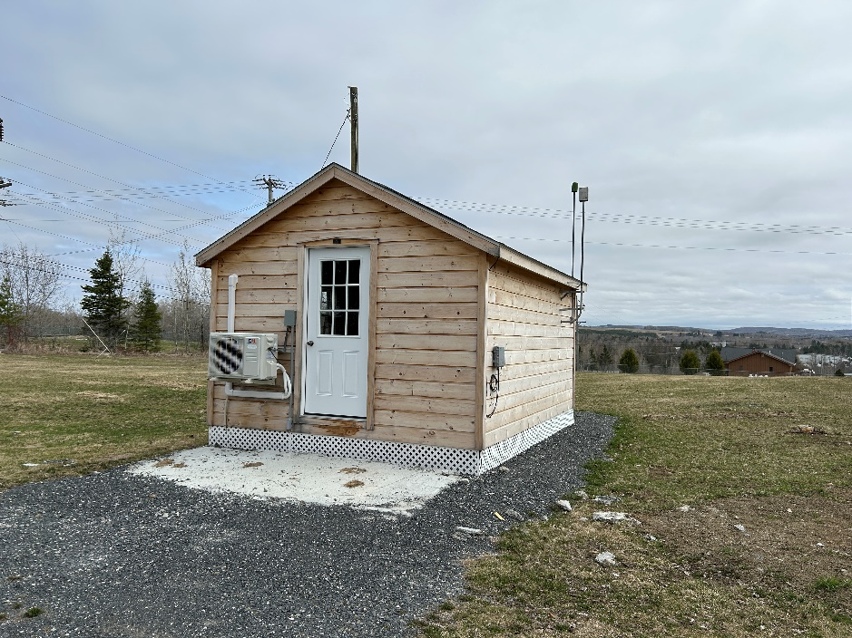
Planned Changes: A step leading into the shelter is to be added to improve egress.

Town – Site: | Passamaquoddy Tribe- Pleasant Point - Sipayik
County: | Washington
Address: | 176 County Road
AQS Site ID: | 23-029-0033
Spatial Scale: | Regional
Statistical Area  (CBSA): | None
Latitude: | 44.963894
Longitude: | -67.061325
Elevation: | 4 meters
Year Established: | 2021
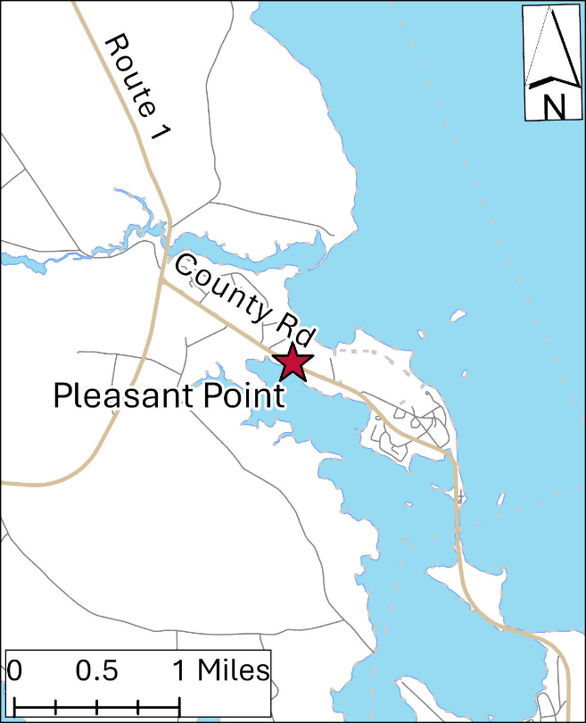
Site Description: Located in a field off route 190 on the way to Eastport.

Parameters Monitored:

- Ozone
- Continuous PM_{2.5}

Monitoring Objectives:

- Forecasting and Mapping
- Population exposure

Planned Changes: The tribal air program may install the meteoritical tower when time allows. The Tribal program is open to monitoring other pollutants if resources are available.
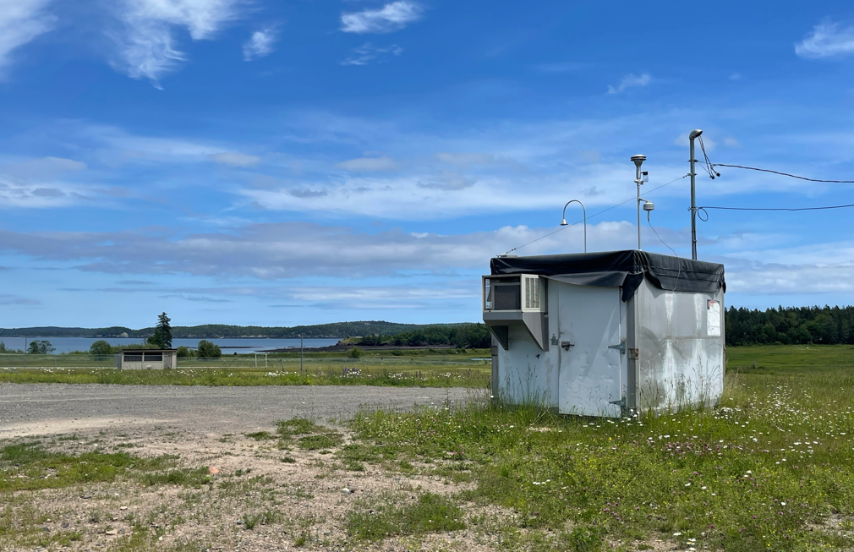
Town – Site: | Penobscot Nation – Carrabassett Valley – Town Office
County: | Franklin
Address: | 1001 Carriage Rd  Carrabassett Valley
AQS Site ID: | 23-007-2002
Spatial Scale: | Regional
Statistical Area  (CBSA): | None
Latitude: | 45.0802
Longitude: | -70.2118
Elevation: | 264 meters
Year Established: | 2002
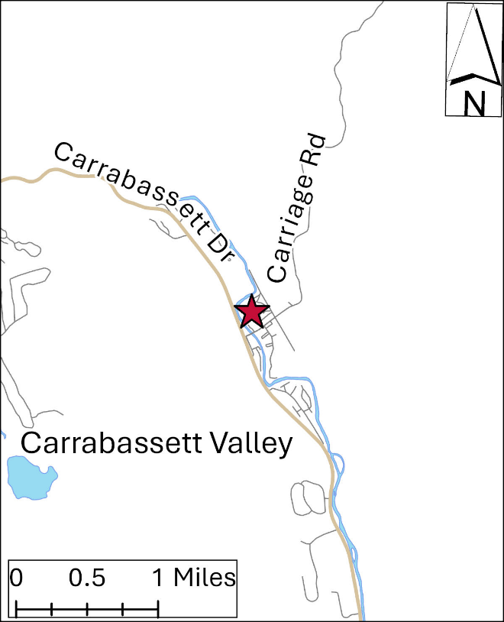
Site Description: Located in an open field behind the town office building.

Parameters Monitored:

- Precipitation accumulation
- Precipitation chemistry
- Mercury

Monitoring Objectives:

- NADP/MDN for the Penobscot Nation
Planned Changes: None.
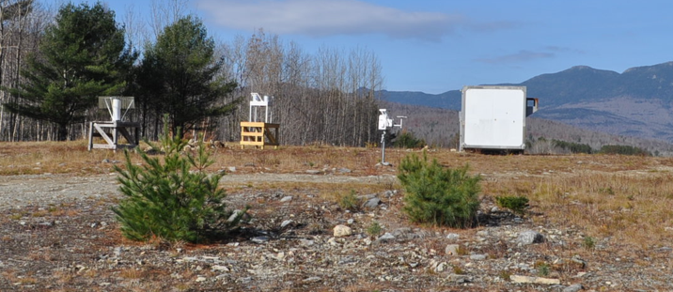
Town – Site: | Penobscot Nation – Indian Island
County: | Penobscot
Address: | 27 Wabanaki Way
AQS Site ID: | 23-019-1100
Spatial Scale: | Regional
Statistical Area  (CBSA): | None
Latitude: | 44.95204
Longitude: | -68.64768
Elevation: | 41 meters
Year Established: | 2006
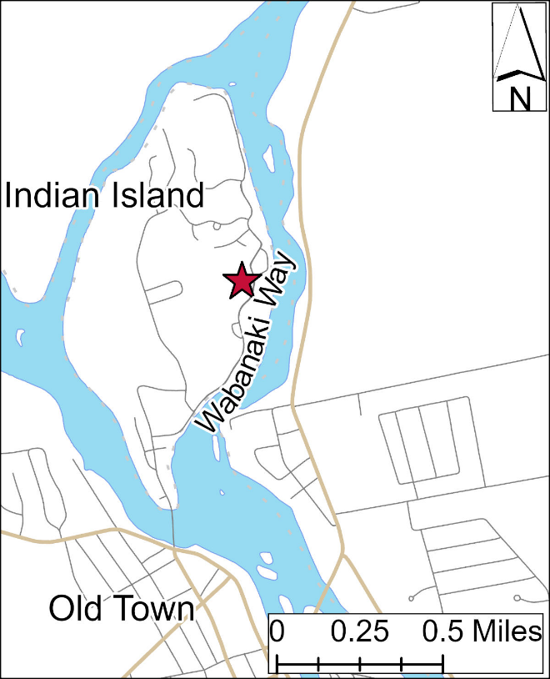
Site Description: Located in the Pavilion Park on Indian Island.

Parameters Monitored:

- Speciated PM_{2.5}

Monitoring Objectives:

- IMPROVE
- Environmental monitoring for the Penobscot Nation

Planned Changes: None.
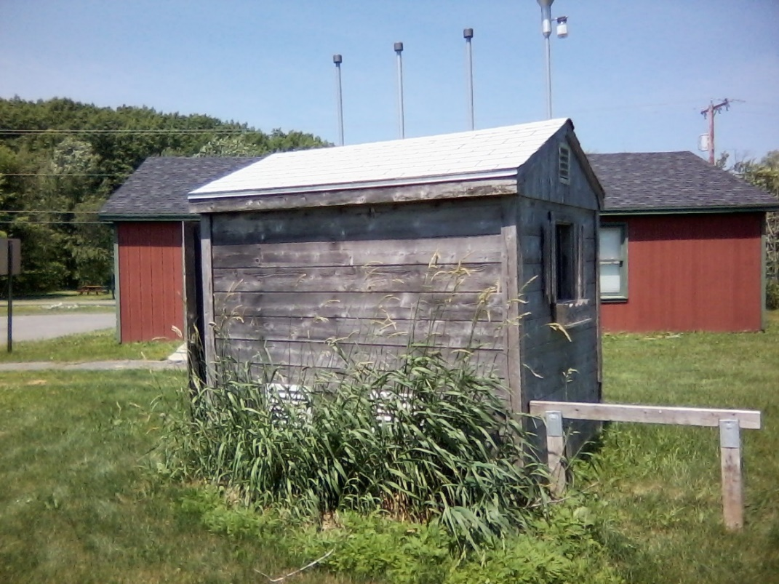

Appendix 2:
Wyman Station
Update Provision of US EPA’S
2015 Data Requirements Rule

Additional Data to Satisfy Update Provision of
USEPA’s 2015 “Data Requirements Rule”
On August 21, 2015, the United States Environmental Protection Agency (US EPA) finalized the “Data Requirements Rule for the 2010 1-hour Sulfur Dioxide (SO₂) Primary National Ambient Air Quality Standard” (DRR) which requires all states to characterize ambient SO₂ levels in areas with large sources of SO₂, specifically for the purpose of demonstrating each source’s attainment of the 1-hour SO₂ National Ambient Air Quality Standard (NAAQS).
The DRR, which establishes minimum criteria for identifying sources that may be selected for further examination, states that “…each air agency is required to submit a list to the US EPA by January 15, 2016, that identifies all sources within its jurisdiction that have SO₂ emissions that exceeded a 2000 ton per year annual threshold during the most recent year from which emissions data for that source are available”.
In a January 13, 2016, letter from the Maine Department of Environmental Protection (Maine DEP) to the US EPA Region I Air Programs Branch Chief, Maine DEP informed US EPA that it did not have any individual sources with actual reported SO₂ emissions exceeding 2000 tons per year (using the three-year period 2013 – 2015). The letter further stated that Maine did not anticipate that any of its currently regulated sources would likely emit in excess of 2000 tons per year of SO₂ in the foreseeable future.
In a March 17, 2016, response letter from US EPA’s Regional Administrator to Maine DEP, US EPA stated that they had reviewed Maine’s January 13th submittal and were identifying William F Wyman Station (Wyman Station), located in Yarmouth Maine, as a source that the DRR requires to be characterized. US EPA’s basis for the request cited “Though total annual SO₂ emissions from Wyman have declined in recent years, it appears that Wyman’s operation from month-to-month is highly variable, and that may continue into the future. For example, in 2015, Wyman had 22 days with SO₂ emissions greater than 40 tons per day. Therefore, the US EPA believes that it is appropriate and necessary to characterize William F Wyman under the Data Requirements Rule.”
In addition, the March 17th letter stated that each air agency must identify the approach that it will use to characterize air quality in the source’s respective area by July 1, 2016. Under the DRR, each state must indicate if they will use current representative monitoring data, perform ambient dispersion modeling, or establish federally-enforceable SO₂ emissions restrictions in the source’s Title V permit. If the state chose either the ambient monitoring or dispersion modeling options, the DRR required that the appropriate protocol be submitted by July 1, 2016.
On June 29, 2016, Maine DEP sent a letter to inform US EPA that performing air dispersion modeling was the chosen option for Wyman Station. Attached to the June 29th letter was Wyman Station’s air dispersion modeling protocol which provided in-depth discussions of methodologies and assumptions being proposed for use in the modeling demonstration. After several iterations of written correspondence to resolve questions regarding the modeling protocol, Maine DEP received agreement from US EPA that the protocol was acceptable. Maine DEP, in close consultation with Wyman Station, conducted an air dispersion modeling analysis using US EPA-approved models and modeling guidance/techniques in a manner consistent with the approved June 2016 modeling protocol. The DRR required that Wyman Station’s final modeling analyses, results and all supporting documentation be submitted to US EPA by January 13, 2017.
On January 11, 2017, Maine DEP submitted Wyman Station’s dispersion modeling results and associated files to US EPA. The results, which were based on 2013-2015 hourly current-actual emissions data, demonstrated that Wyman Station was in compliance with the 1-hour SO₂ NAAQS. On March 9, 2017, Mane DEP was contacted by US EPA Region I Air Quality Modeling Manager, Leiran Biton, via telephone stating that the modeling submitted by Maine DEP was complete and acceptable to meet the requirements of the DRR.
Federal regulation 40 CFR Part 51 Subpart BB §51.1205(b) states, “For any area where modeling of actual SO₂ emissions serve as the basis for designating such area as attainment for the 2010 SO₂ NAAQS, the air agency shall submit an annual report to the EPA Regional Administrator by July 1 of each year, either as a stand-alone document made available for public inspection, or as an appendix to its Annual Monitoring Network Plan (also due on July 1 each year under 40 CFR 58.10), that documents the annual SO₂ emissions of each applicable source in each such area and provides an assessment of the cause of any emissions increase from the previous year. The first report for each such area is due by July 1 of the calendar year after the effective date of the area's initial designation.”
Since the effective date for Maine’s final SO₂ designation was April 9, 2018 (as published in the January 9, 2018 Federal Register), Maine is submitting the following additional information to meet the above requirements:
As stated previously, Wyman Station’s modeling demonstration utilized hourly current-actual emissions and stack flow data from the calendar years 2013 – 2015. The two tables below lists the ton per year (TPY) emissions for the three years modeled (2013 - 2015) as well as the most-recent three-year period (2023 – 2025).

Modeled Years Emissions
Calendar Years | Actual SO₂ Emissions (TPY)
2013 | 861.16
2014 | 844.03
2015 | 1750.67

Most Recent Three-Year Period Emissions
Calendar Years | Actual SO₂ Emissions (TPY)
2023 | 172.42
2024 | 146.77
2025 | 576.78
Annual actual SO₂ emissions for the most recent three years show that Wyman Station’s emissions are significantly lower than those modeled for the 2013 - 2015 period, the timeframe that served as the basis for US EPA’s identification of Wyman Station as a DRR source.
There are several factors that can account for these lower TPY values: Wyman Station is primarily relied upon as a peaking power plant (i.e., generally operates only when there is a very high demand for electricity), the migration toward lower sulfur fuel oil, and a more consistent supply of natural gas, etc.
The following information was contained in a December 19, 2018 letter from Wyman Station to Maine DEP: “Pursuant to 40 CFR 75.61 (a)(7), FPL Energy Wyman, LLC is hearby providing notice that Units 1 and 2 at the Wyman facility have been shut down, and placed into long-term storage as defined in §72.2. Shutdown of the unit occurred on October 1, 2018 at 0000 hours.” The letter further states that “…the duration of the shutdown is expected to last for at least two years…” Units 1 and 2 continue to remain in long-term storage given that Wyman Station has reported zero emissions for both units from 2019 through 2024.
Given that Wyman Station is primarily relied upon as a peaking power plant, Wyman Station’s migration toward lower sulfur fuel oil and several of Wyman Station’s units remaining in long-term storage, Maine DEP does not anticipate a significant increase in future SO₂ emissions from Wyman Station.
Therefore, when all of the above factors are considered, Maine DEP finds that the modeling results required by the DRR demonstrate that Wyman Station remains and will continue to remain in compliance with the 1-hour SO₂ NAAQS. Per requirements of the DRR, Maine will continue to update Wyman Station’s SO₂ actual TPY emissions (as seen in Table 1) and report those values to US EPA as part of Maine DEP’s Annual Air Monitoring Plan each subsequent year. Should Wyman Station’s actual TPY emissions increase significantly above those 2013 – 2015 values used in the analysis, Maine recognizes that an updated modeling demonstration may be required.

Federal Aviation Administration initiative to eliminate leaded aviation fuels: “https://www.faa.gov/unleaded#:~:text=The%20FAA%20and%20partners%20launched%20the%20EAGLE,or%20eliminate%20reliance%20upon%20leaded%20aviation%20fuels”
EPA webpage on the NCORE monitoring network: https://www.epa.gov/amtic/ncore-monitoring-network#:~:text=NCore%20is%20a%20multi%20pollutant,‌‌‌network‌%20on%‌‌​20January%201%2C%202011
US Code of federal Regulations, Part 58 – Ambient Air Quality Surveillance: https://www.ecfr.gov/current/title-40/chapter-I/subchapter-C/part-58
EPA CASTNET webpage: https://www.epa.gov/castnet
NESCAUM Hazecam network webpage: https://www.hazecam.net/
EPA RadNet webpage: https://www.epa.gov/radnet

